A oes gennych chi boen / broblem gyda Chymal / Asgwrn / Cyhyr / meinwe cysylltiol?
A ydych angen gwybodaeth / eich cyfeirio?

Ewch ar:-
Wefan Bwrdd Iechyd Betsi Cadwaladr:-
https://bipbc.gig.cymru/

Chwiliwch MSD - dewiswch ac agorwch Dudalen ARMA Page o’r Canlyniadau Chwilio

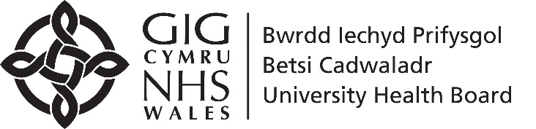

Do you have a Joint / Bone/ Muscle/ Connective tissue problem / pain?
Need Information / signposting?

Visit:-
Betsi Cadwaladr University Health Board
Webpage:-
https://bcuhb.nhs.wales/

Search MSD - select and open
ARMA Page from Search Results

