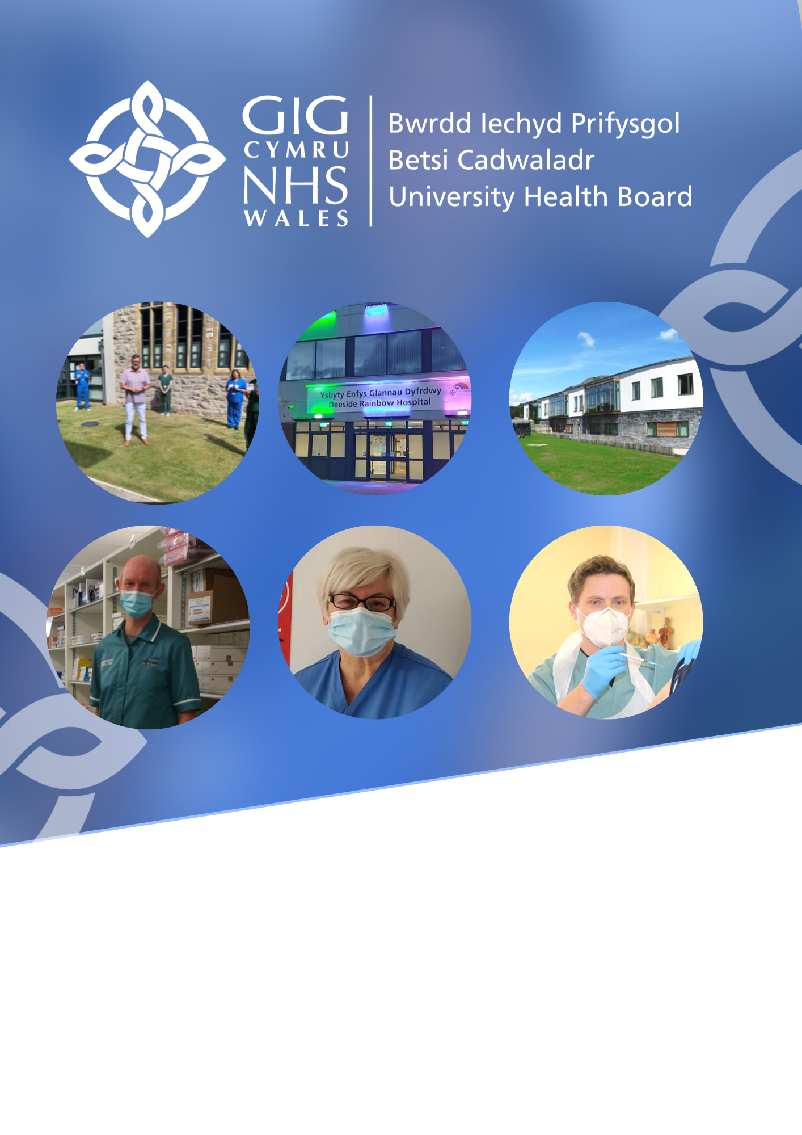

We th
Annual Plan 2021 to 2022
Shaped by a Three Year Transformation Plan
2021 to 2024
2nd July 2021

Chairman and Chief Executive Foreword
The last year has undoubtedly been the most challenging in the history of the many NHS organisations that have served the people of North Wales. Responding to the pandemic has required us to develop and implement new services such as Test Trace and Protect (TTP), mass COVID-19 vaccination, and establish three Enfys hospitals at high speed. We have also redeployed staff into other pressurised services, for example critical care, to increase their capacity to an unprecedented scale. Some important activities, such as much of planned care have been severely interrupted or stopped due to the constraints deriving from COVID-19, causing worry to patients and in some cases, harm. This has also been the cause of significant concern for the organisation and the clinical teams responsible for carrying out said activities. All told, it would be hard to find a member of staff who has not had the most disruptive and difficult year of their working lives. We are incredibly grateful for their professionalism and sheer hard work, and do not underestimate the toll this has taken on individuals and teams.

One of our new services has been our programme for mass vaccination, and the success of this programme, mirrored across the rest of the UK, gives us a glimmer of confidence about the future. Of note have been a range of genuine service improvements driven by the need to work differently due to the pandemic and there are many examples of different specialisms and localities working cooperatively to maintain, and in some cases extend, services. There has been a real receptiveness to working in new ways: we have embraced new digital technologies and rediscovered the value of our partnerships with local authorities, and many others. All we have achieved, we have achieved through working together and we would like to acknowledge all our partners during this year. One example of many, has been the determination and community spirit displayed in rapidly and successfully trialing the use of the COVID-19 Pfizer vaccination in primary care on the Llyn peninsula.

Away from the pandemic, we have demonstrated sufficient progress to be taken out of ‘special measures’ and into ‘targeted intervention’, although we are clear there is much work that remains to be done to build a genuinely fit for purpose and integrated organisation and so, as always at this time of the year, we are turning our attention to plans for the coming year.

COVID-19 will remain as our most significant focus at least for the first half of 2021/22 as will moving into a service recovery phase. We are concerned about the tens of thousands of people who have now been waiting even longer to receive care. This is one of our core priorities, alongside looking at enhanced pathways for urgent and emergency care, and re-engaging with our vital longer term work to improve population health.

To achieve our priorities we will engage with our workforce, partners, and the wider communities of North Wales in new and innovative ways over the next 12 months and beyond.

Thank you for taking the time to read our plan and we look forward to working with our people, patients, and partners as we continue to grow and improve our services for the benefit of the people of North Wales.



Jo Whitehead
Chief Executive
Mark Polin
Chairman
Betsi Cadwaladr University Health Board

Plan for 2021/2022 in the context of a three year transformation programme
Contents
Chairman and Chief Executive Foreword 2
1. Introduction 4
2. Our vision for the future 7
3. Our approach to longer term transformation 16
4. Tackling immediate priorities in 2021/22 22
6. Key performance lessons learnt and challenges for 2021/22 44
7. Key integrated planning assumptions
– COVID-19 workforce and finances 48
8. Strengthen our Wellbeing Focus 50
9. Recovering access to timely planned care pathways 53
10. Improved unscheduled care pathways 64
11. Integration and improvement of mental health services 68
12. Enablers 73
13. Risks and issues 95

Introduction

BCUHB Plan on a page for 2021/22
A Healthier Wales
NHS Vision
Key Priorities
Covid-19 response
Improvement and involvement Mental Health Services
Recovery of access to planned care pathways
Strengthen our wellbeing focus
Unscheduled care pathways
What the people of north Wales can expect
Health professionals working in primary care enabled to undertake remote consultations, share information with patients and to update the patients’ clinical records. Improved patient access to services, whilst maintaining social distancing protocols and improving delivery of GMS standards.
Additional urgent primary care capacity in place to support practices and emergency department service delivery, through the implementation of Urgent Primary Care Centres.

Transformation of Community Services through development of the Home First Bureau to reduce unnecessary admissions into hospital, with pathway improvements to keep to delays to a minimum. More patients receiving care at home rather than in hospital.
Increased capacity to improve access to care for children who require neuro-developmental assessments.
Delivery of planned care recovery schemes to reduce cohort 1 Covid-19 backlog for all over 52 week waiters by March 2022.
Dedicated urological specialist teams supported by robotic assisted surgery facilities to improve patient outcomes, reduced complication rates, less pain and quicker return to normal activities.
Roll out of mental health practitioners into primary care settings, and introduction of community connector roles in localities to support patients struggling with their mental health.
Improve care closer to home opportunities in the eye care programme, improving the care of patients at risk of irreversible sight loss, and maximising eye health and sight retention for the north Wales population. Improved access and elimination of the current waiting list backlog.
Consistently higher clinical outcomes in stroke care through early supported discharge and provision of specialist, integrated, inpatient and community rehabilitation services.
Strengthened emergency departments, delivering improved access to services in line with the Welsh access model, including a ‘contact first’ system, a ‘streaming hub’ and ‘waiting & care’, leading to more efficient navigation of patients.
Recovery programme for planned care, supporting improved access to diagnostic and treatment services for patients.
Development of cancer services and implementation of the new single cancer pathway, ensuring more timely care, in line with national standards.
Improve population health and well-being
Better health and social care services
Health and social care workforce
Higher value health and social care
Enablers
Finance
Workforce
Estates
Governance
New ways of working
Organisational development
Consult and engage with patients, public, staff and stakeholders

The principal role of the Health Board is to ensure the effective planning and delivery of healthcare for people for whom it is responsible, within a robust governance framework. This will allow us to achieve the highest standards of patient safety and public service delivery, improve health, reduce inequalities and achieve the best possible outcomes for its citizens, in a manner that promotes human rights.
This plan has been developed in the context of the unique challenges arising from the pandemic, which face all public services and society at large. It reflects the challenges the Health Board has to address in delivering health services, whilst supporting and protecting staff.
Alongside the delivery of our immediate priorities, we are building on relationships and existing partnership structures and we will be fully engaging and involving the public, staff, trade unions and partners in the transformation and reshaping of services.
The essential first step will be to work in partnership to build a sustainable vision for the future. This will lead to an integrated medium term plan being developed in readiness for 2022/23, with a focus on prevention, physical and mental well-being, population health, primary care and hospital services. Effective partnership working will be essential to improving the delivery of services we provide to the population of North Wales.
Work to tackle the COVID-19 pandemic has served to further galvanise partnership working at a local, regional and national level where we are actively engaged in a number of all Wales programmes. Our Plan recognises the work that is required in partnership to support vulnerable communities and protect the health and wellbeing of the population to support the principles of ‘A Healthier Wales’.
We will continue to build upon existing local, regional and national partnerships, for example, working as part of the North Wales Regional Partnership Board on the transformation and reshaping of services.
The Health Board will work to deliver transformation and innovation, aiming to deliver improved outcomes, performance, patient experience and financial performance year on year. These improvements will contribute to the actions required to demonstrate progress against the Targeted Intervention Framework published by Welsh Government.

Achievements 2020/21

The Health Board faced unprecedented challenges during 2020/21 as a result of the pandemic. The response of our staff, partners and the many volunteers who came forward to support us enabled significant achievements, as set out below:
- Maintaining essential services for our patients;
- Rapid establishment of the Test, Trace, Protect service;
- Delivering ‘home first’ services, discharge to assess pathways and support to care homes in partnership with local authorities and third sector organisations;
- Supporting and protecting our staff, including the establishment of staff support and wellbeing hubs;
- Development of ‘red hubs’ to ensure patients had access to primary care services, including urgent dental care, eye care and general medical services;
- Ensuring an effective response to COVID-19 demand on hospitals including the second peak of activity and managing local outbreaks with our partners;
- Commissioning of 3 temporary Enfys Hospitals in Llandudno, Deeside and Bangor, delivered high quality clinical facilities at speed and in conjunction with local authority and education partners;
- Establishment of a clinical advisory group facilitating rapid roll out of new digital technology and pathways of care;
- Rapid establishment of the mass COVID-19 vaccination programme across North Wales; and
- Removal from Special Measures and progression to Targeted Intervention escalation status, and achieving financial balance within the resources allocated by Welsh Government.

What the people of North Wales can expect

A number of significant developments within our plan are set out below to illustrate what our plan is seeking to deliver for our population in North Wales:
- Further roll out of digital technology with more virtual appointments provided in primary care and within our hospitals. Access to appointments improved due to having more options for timely consultations. This will also reduce patients having to travel for services and reduce the risk of COVID-19 spread and will be safer for staff and patients;
- Improved care for children and young people in crisis so they are treated in the right place at the right time and as close to home as possible;
- Increased capacity will support improved access to care for children who require neuro-developmental assessments;
- Roll out of the mental health practitioner model and community connector role to localities to improve support to patients within primary care;
- The development of pathfinder urgent primary care centres to ensure timely, efficient care for patients with urgent primary care needs and reduce demand for minor illness / injuries on our Emergency Departments. The service will create more capacity for GP practices to better manage patients with more complex conditions;
- By strengthening our emergency departments, we will deliver improved access to services in line with the Welsh access model including a ‘contact first’ system, ‘streaming hub’, and ‘wait & care system’, leading to more efficient navigation of patients;
- Developments in cancer services and implementation of the new single cancer pathway will ensure more timely care for our patients in line with expected national standards;
- Patients will receive consistently higher clinical outcomes in stroke care through early supported discharge and provision of specialist integrated community in-patient rehabilitation services;
- The planned care recovery programme will support improved access to diagnostic and treatment services for patients;
- The eye care programme will optimise care closer to home and improve the care for patients at risk of irreversible sight loss, maximise eye health and sight retention for the North Wales population including improved access and elimination of existing waiting list backlog;
- The prehabilitation programme, including for example, conservative management for early onset osteoarthritis, will maximise patient fitness prior to treatment and avoid or shorten hospital stays wherever possible;
- Building capacity within to retain and sustain improvement through a network of 1800 champions, connectors and influencers in order to grow a BCUHB social movement of change;
- Dedicated urological specialist teams supported by robotic assisted surgery will improve patient outcomes, reduce complication rates and deliver improved access for patients with less pain and quicker return to normal activities;
- The Home First bureau (operating 08.00 – 20.00 daily) will support patients to return to the best life possible following their period of illness, through maximising the opportunity for active therapeutic input and support to patient discharge from hospital. This will reduce delay in transfers of care leading to shorter length of stays within hospitals and increase in patients returning home rather than having to be cared for in a community bed;
- Care home quality nurses will work with the care home sector to deliver safe effective care to the residents of North Wales. Quality of life will be enhanced by ensuring patients receive the care and support they need, have a positive experience of care and are safeguarded and protected from avoidable harm; and
- Implementation of an audiology led earwax management pathway will provide care closer to home, improve patient experience and reduce unnecessary onward referrals to secondary care ENT and audiology services.

Our vision for the future

The Health Board’s vision is to create a healthier North Wales, that maximises opportunities for everyone to realise their full potential, reducing health inequalities. This means that, over time, the people of North Wales should experience a better quality and length of life.
We aim to provide excellent care, which means that our focus for the next three years will be on developing a network of high quality services, which deliver safe, compassionate and effective care based on what matters to our patients. We will ensure our work is closely aligned with Welsh Government’s long-term vision for achieving a ‘whole system approach to health and social care’.
To do this we will:
- Improve population health and well-being through a focus on prevention;
- Improve the experience and quality of care for individuals and families;
- Enrich the well-being, capability and engagement of the health and social care workforce; and
- Increase the value achieved from funding of health and care through improvement, innovation, use of best practice, and eliminating waste.

Our strategy: Living Healthier, Staying Well

As we move forward into the COVID-19 recovery phase, it is timely to take stock and check with our staff, patients, partner organisations and the public how COVID-19 has affected health and well-being and what we can learn from this experience.
We also want to check on the progress of our long-term strategy for health, well-being and healthcare, Living Healthier, Staying Well (LHSW). It has been three years since we developed this. Change takes time, and we need to check whether we are achieving what we set out to do, and whether the principles and priorities are still relevant. To facilitate this we are beginning a review and refresh of LHSW, and will:
- Check in with our staff, patients, partners and public whether the principles are still valid;
- Review our strategic priorities to ensure they are consistent with ‘A Healthier Wales’;
- Address those elements of LHSW that proved challenging to implement e.g. an integrated system wide approach to healthcare and integrated care pathways;
- Test the strategy is still relevant in the changed environment;
- Provide the framework for development of a Clinical Services Plan.

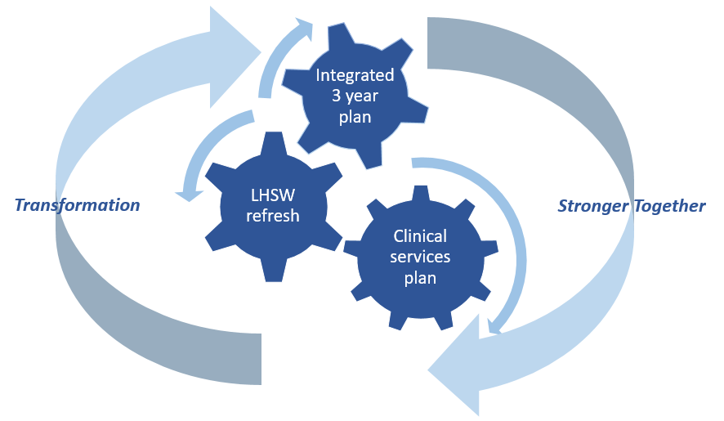
We are developing a discussion paper and will be asking people – patients, carers, community groups, partner organisations and others – for their views. The refresh work will be completed by the autumn to feed into the development of the integrated three year plan 2022/25 and to provide the basis for the clinical services plan.

Carers Strategy

The Health Board continues to work closely with carers and we remain committed to working and engaging with service users, patients, families, carers and the wider public. Within the forthcoming 12 months utilising co-production we will be undertaking a carers mapping exercise across all carers age groups and self-assessment. This gap analysis will support the development of our 2021 – 2024 Three Year Carers Strategy and implementation plan adopting a therapeutic alliance approach with our service users, professionals and carers.

A Healthier Wales

Our vision and strategy is aligned to ‘A Healthier Wales’, which sets out a long-term future of a ‘whole system approach to health and social care’. This is focussed upon:

- Health and well-being, preventing illness and enabling people to live independently for as long as they can, supported by new technologies;
- Integrated health and social care services which are delivered closer to home; and
- Close collaborative working to impact on health and well-being throughout life.

These are consistent with the aims of our living healthier, staying well strategy which is aligned to the expectations of Welsh Government as illustrated below:

‘A Healthier Wales’ |  | …How we deliver locally:
Health and social care system to work together |  | - Regional Partnership Board and other partnerships supporting integrated planning and delivery;  - Expansion of community resource teams;  - Delivering our unscheduled care model with our partners.
Shift services from hospital to community |  | - Health and well-being centres;  - Eye care plan, delivering more care through primary care optometry services;  - Unscheduled care pathways;  - Mental health services delivery plan;
Get better at measuring what really matters |  | - Revised performance and accountability framework;  - Stronger governance arrangements;
Make Wales a great place to work in health and social care |  | - Workforce strategy: staff engagement, leadership, culture and climate, motivation, innovation and learning;
Work together in a single system |  | - Medical and Health Sciences School;  - Unscheduled care / emergency ambulance services commissioning;  - Mid Wales healthcare collaborative;  - Commissioning secondary and specialist services.

  - Programme for Government

Our plan supports key elements of the delivery of Welsh Government Programme for Government (published on 15th June).
Our recovery plans are aligned to the Programme for Government and detail how we will move forward following the extraordinary challenges the Health Board have faced this year. We are investing in our staff, and our services to overcome the backlog caused by the pandemic and to build on existing services, utilising new ways or working, integrating with social care partners, taking a cohesive approach to delivering care in North Wales. Specifically we will:
Protect, re-build and develop services for vulnerable people;
Build a stronger, greener economy as we progress towards decarbonisation;
Celebrate diversity and move to eliminate inequality in all of its forms; and
Provide effective, high quality and sustainable healthcare. Key examples of which include:
Programme for Government plans | Example of what we have planned
Establish a new medical school in North Wales | Promoting ‘train, live and work in North Wales’, retaining local skills and attracting employees to North Wales
Provide treatments which have been delayed by the pandemic | Using our 6 point plan to tackle and recover from COVID-19 impact on planned care service
Deliver better access to doctors, nurses, dentists and health professionals | Utilising new ways of working, including the piloted AccuRx scheme used throughout the pandemic
Reform primary care, bringing together GP services with pharmacy, therapy, housing, social care, mental health, community and third sector | Developing urgent primary care centres so as to increase primary care capacity, and supporting emergency services by reducing pressures on service delivery. Developing integrated health and social care localities, with strong links to Primary Care Clusters and Community Resource Teams (CRTs), in order to meet the needs of individual communities across North Wales. Embed mental health within core CRT delivery. Identify opportunities to work with the National Primary Care Programme
Prioritise investment in mental health | Developing and implementing new services including increased access to services and early intervention programmes supported by the transformation fund. See Section 11
Prioritise service redesign to improve prevention, tackle stigma and promote a no wrong door approach to mental health support | Developing our services further in terms of CAMHS, ICAN, older people crises and more. Ensuring multi-disciplinary staff are trained to provide best quality services for patients Actively support staff in their workplaces to maintain optimum wellbeing
Roll out CAMHS ‘in-reach’ in schools across Wales | Joint working with social and educational services within schools  Establishing and implementing effective and timely transition arrangements that support young people into adult services
Introduce all-Wales framework to roll out social prescribing to tackle isolation | Piloting elemental software which enables social prescribing projects to monitor progress at an individual and programme level. Understanding the demand, delivery and impact of social prescribing in North Wales so we can better develop our plans for meeting the population needs
Review patient pathway planning and hospice funding | Within the forthcoming 12 months utilising co-production we will be undertaking a carers mapping exercise across all carers age groups and also a self-assessment. This gap analysis will support the development of our 2021 – 2024 Three Year Carers Strategy and implementation plan adopting a therapeutic alliance approach with our service users, professionals and carers
Focus on end-of-life care | Exploring models of end of life care in partnership with hospices to ensure improved access across North Wales and so that more patients can be cared for closer to their homes.
Invest in and roll-out new technology that supports fast and effective advice and treatments | Identifying new ways of working for future effective service delivery, including the eConsult and Attend Anywhere programmes. Working with partners to develop a digital strategy for personalised care and support, aligned to the role of equipment stores and telecare/ telehealth services
Introduce e-prescribing and support developments that enable accurate detection of disease through artificial intelligence | Build upon remote prescribing opportunities during and post the COVID-19 pandemic through the EMIS GP prescribing system, allowing our clinicians to prescribe from remote sites and when working from home, supported by a ‘remote prescribing policy’  Respond to the outcome of the WG independent e-prescribing review when published
Invest in a new generation of integrated health and social care centres across Wales | Respond to the review of primary care estates commissioned by WG  Completion of the new WG funded developments in Waunfawr and Ruthin  Further the development of CRTs and co-location of integrated teams
Establish new Intensive Learning Academies to improve patient experiences and outcomes | Supporting the further implementation of the primary care model in Wales, leading new ways of working and innovation in primary care. Promoting a sustainable Dental Therapist / Nurse workforce in North Wales by providing expanded local opportunities and training for dental staff, which will improve skill mix, recruitment and retention
Develop local community hubs to co-locate front-line health and social care and other services | Our Well North Wales work has benefited from Early Years and Prevention funding which has helped to develop a more integrated service concerning homelessness and food poverty. Providing access to the right information, when needed to improve mental health and wellbeing e.g. number of individuals supported through our ICAN community hubs

Equality, diversity & inclusion

The Health Board has a Strategic Equality Plan (SEP) which provides a framework to help ensure that equality is properly considered within our organisation and influences decision-making at all levels. The SEP sets out the steps we are taking to fulfil our specific duties under the Equality Act 2010 (Statutory Duties) (Wales) Regulations 2011 and describes the Health Board’s arrangements for equality impact assessment. We have gathered and analysed relevant information and are maintaining engagement with communities, individuals and experts to help inform our direction.

It is well recognised that COVID-19 has further magnified inequalities for many people with protected characteristics and those who are socio-economically disadvantaged. For some individuals, these inequalities may also be increased further by barriers to accessing healthcare, marginalisation from society or discrimination. As part of our recovery and as planned care restarts and the focus is on those people who are most in need of urgent treatment it is necessary to ensure equality considerations are built into plans. Our equality impact assessment procedures and tools have been further developed as a framework to help identify and mitigate impact and provide an overview of some of the barriers to accessing healthcare for further consideration.

Key themes include: ensuring accessible communication and information, making reasonable adjustments, addressing the barriers experienced by disabled or neuro divergent people, meeting the needs of those with sensory loss, considering socio-economic disadvantage, mitigating for digital exclusion and optimising opportunities for engagement and co-production.

In addition to the immediate enhancement of impact assessment guidance, our plans to deliver the SEP have been reviewed to reflect this emerging evidence. Further information about the SEP and equality objectives is published and available here.

Welsh language

The Health Board has sought to demonstrate its commitment to promoting the use of the Welsh language over a number of years. Our Welsh language strategic forum continues to provide leadership, commitment and operational support to ensure the Welsh language is embedded within all our services. Ongoing development and compliance with the Welsh Language Standards under the Welsh language (Wales) Measure 2011 and ‘More than just words’ will be continuously monitored to ensure needs and demands are assessed and managed, whilst maintaining an ethos of quality improvement.
This focus provides clarity on the importance of the Welsh language in developing new services, influencing organisational behaviour and actively offering patient-centred Welsh medium care. Our Welsh language key priorities plan will continue to ensure organisation-wide consistency in delivering the Welsh Language Standards, provide timely translation services to staff, patients and the public, and build on the ‘active offer’ approach to services so that patients are offered timely access to language appropriate care.

Sustainability





The Health Board recognises the need to change the way we work, ensuring that we increasingly adopt the sustainable development principles defined within the Well-being of Future Generations Act: this means taking action to improve economic, social, environmental and cultural well-being. There are five ways of working set out in the Act, which we need to think about when working towards this:

Throughout the development of our plan we have sought to use the five ways of working to inform our decisions and help us prioritise the actions we will take to work towards our own well-being objectives and in turn, contribute to the seven national well-being goals. Examples of this approach are set out in the table below:
 |  | Selection of work programmes supporting the ways of working within the Health Board:
Long-term | - New single cancer pathway across North Wales delivering the national target of 75% of all patients achieving the single cancer pathway;  - Development and commencement of implementation of long term plans for sustainable diagnostic services (radiology and neurophysiology);
Integrated | - Urgent primary care centres to be piloted, supporting an integrated model of unscheduled care;  - Develop the stroke service model focusing initially on early supported discharge and rehabilitation to deliver improved outcomes, supporting improved compliance with stroke guidelines;  - Develop sustainable endoscopy service across North Wales;
Collaboration | - Home First bureau consolidation and mapping all of our resources to support discharges including continuing healthcare, home first bureau, frailty, discharge to recover then assess (D2RA) therapies, and community resource teams;  - Outpatient transformation programme, end to end pathway redesign, ‘Once for North Wales’, workforce modernisation and digital enablement of staff and service users;
Involvement | - Deliver community food poverty education programmes within North Wales communities, to reduce food poverty - aligned to the Welsh Government initiative for ‘A Healthier Wales’;  - Develop an appropriate interface with CAMHS to ensure effective transition for young people with mental health conditions into adult services;
Prevention | - COVID-19 vaccination programme and development of a sustainable delivery model / annual vaccination programme;  - Support the ‘Sport North Wales’ development/ approach.

Whilst demand for healthcare continues to grow, the Health Board is committed to meeting the challenges of achieving carbon reduction, waste reduction and securing products and resources from sustainable sources where possible to ensure that our environmental impact is reduced as far as is reasonably practicable.
As part of our corporate commitment towards reducing our impact, we maintain a formal environmental management system (EMS) designed to achieve sustainable development, compliance and mitigation against the impact of climate change, in a culture of continuous improvement.
Effective environmental management is achieved through:
- Promotion of the environmental policy to all relevant stakeholders;
- Identification of all significant environmental aspects and associated legal requirements;
- Establishing objectives and monitoring targets aimed at reducing environmental and financial impacts;
- Provision of appropriate training to all relevant personnel;
- Regular internal and external audits of practice;
- Regular review of the effectiveness of the EMS by the Environmental Steering Group; and
- Working with local, regional, and national partners to ensure best practice procedures are identified and implemented.

Research and innovation
We will continue to deliver our research and innovation strategy working closely with the Research, Innovation and Improvement co-ordination hub in North Wales as part of the all Wales initiative set out in ‘A Healthier Wales’. A key aim in 2021/22 is to work with our partners to develop a North Wales cross sector vision for research and innovation.
In 2021/22, we will continue to recruit to urgent public health COVID-19 studies, reflecting the critical importance of this research contribution at the current time.
We are working closely with Health and Care Research Wales (HCRW), to set out plans for the recovery and resilience of non-COVID-19 research. We are contributing, through HCRW, to the Clinical Research, Resilience and Growth (RRG) UK Programme. Locally, we will re-open paused non COVID-19 studies, aligned to the resumption of clinical services, as well as continuing to seek out new opportunities to open research studies, and embed research and innovation into clinical services.
We will be seeking to build our research capacity by submitting a business plan to Welsh Government for a clinical research centre, which will recruit to both COVID-19 and non-COVID-19 early phase clinical trials. We expect to commence this work in quarter two of 2021/22.
We will develop an infrastructure for innovation, working with the all Wales leads, in order to enable the adoption and spread of innovation, to support the transformation of services and care (see section 3).
Together with Bangor University we have an ambition to develop a transformational inter-professional Medical and Health Sciences School by 2025. This represents a significant opportunity for North Wales that will allow us to align education and training to our clinical strategy, support the delivery of our research strategy and address key challenges in our medical and clinical workforce. In addition, strengthening university links to support the health Board progress for example real time evaluation and outcomes data which will serve to support our value based healthcare work.
We have developed a joint programme structure to support planning for this substantial new development. Our approach for North Wales is being shaped and developed during 2021/22 in line with Welsh Government requirements, subject to ministerial consideration and approval.
Looking forward, we will ensure that we can continuously evidence how our activities meet the University Health Board status criteria through our plans.

Our digital future

The Health Board is committed to harnessing the opportunities presented by digital transformation. Our digital vision is concerned with “transforming the patient experience, safety and outcomes through digital ways of working”. This means putting the experiences of patient, carers and staff at the very heart of what we do. Achieving this involves ensuring that we get the basics right.
This strategic approach is informed by feedback from extensive engagement and supports the delivery of our strategic priorities in Living Healthier, Staying Well and our population and organisational outcomes.
We have identified two critical ambitions, which will drive our adoption of digital technology, as set out in the diagram below:

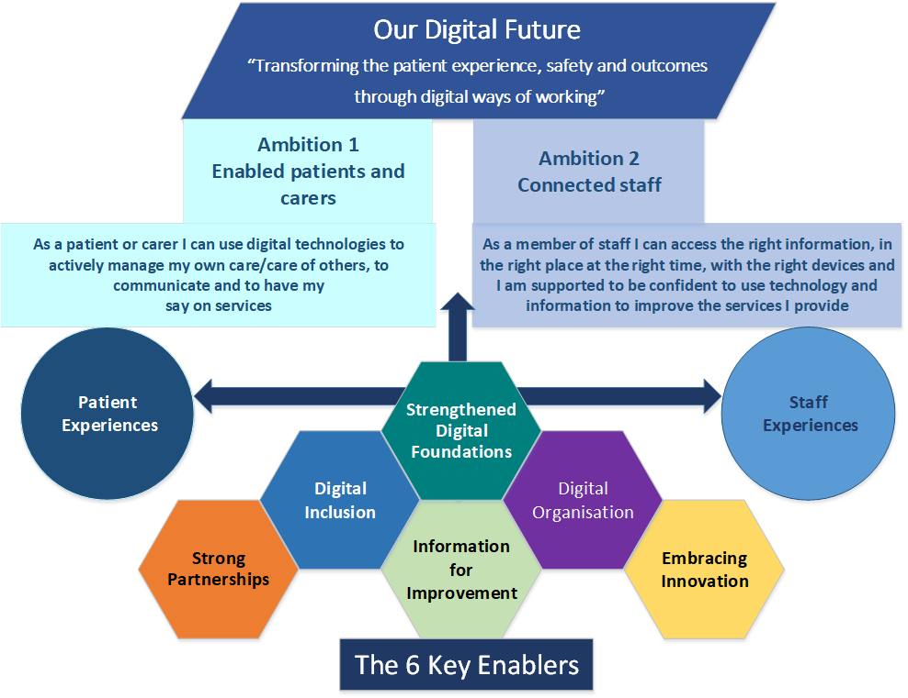

Our approach to longer term transformation
The Health Board has recognised for some time the need to build greater capacity and capability for transformation and improvement. The pandemic has further crystallised the need and wish to do so, whilst also providing a number of opportunities where a post-pandemic ‘new normal’ could be established if we build upon how we have needed to work differently during the pandemic.
In addition, the pandemic has brought further significant challenges in maintaining a safe and secure environment both physically and psychologically for our patients, staff and visitors. These challenges continue to grow and require a renewed focus upon transformation to meet current and future population demand.
Our approach to clinical service transformation is multi-faceted and will be supported by key enabling strategies, covering:
- Quality improvement and patient experience;
- Clinical strategy driving improvement;
- Digitally enabled / digital strategy;
- Workforce strategy and strategic organisational and system development;
- Effective use of all our resources, adopting a Value Based Healthcare approach;
- Innovation, research and development; and
- Ensuring all our physical assets are safe and fit for purpose; maximising capital investment.
As part of the £12m capability strategic funding allocated by Welsh Government, the Health Board has allocated £5.3m in 2021/22 to provide additional capacity to drive forward engagement with our population, staff and stakeholders, to continue to improve governance and to transform clinical and operational services.
The current proposal for the allocation of strategic support to transformation is broken down as follows:
Area for investment to  deliver transformation | Description | Investment £m
Transformation | Resource and systems | 1.9
Engagement | External and internal including clinical service strategy | 1.8
Capacity | Pan BCUHB capacity and capability | 1.1
Public Affairs | Stakeholder and reputation management | 0.5

Successful transformation and improvement activities are not the concern of a single team, but rather something that needs to be embedded across the Health Board, through all of our systems and processes. To do this we will draw upon the experiences of other organisations and invest in a transformation and quality improvement (QI) approach, which is capable of maturing and informing our decision-making.
A proposal of how to deploy an augmented transformational capacity, alongside quality improvement, has been tested with Board members and senior clinicians and managers, and has been positively received. Work on this is now underway and covers transformation at Board level, delivering large or complex programmes or transformation, as well as encouraging our whole workforce to get involved in smaller pieces of transformation that are important to them.
We will supplement our existing QI approaches by building upon the well tested Kaizen methodologies to support continual improvement at every level of our workforce. This approach, along with the broader “toolbox” of methodologies we will use, is summarised below:

Quality Improvement Methodology
We will build our QI and transformation toolbox upon tried and tested approaches.
- Kaizen Principles
Kaizen is generally taken to refer to a collection of concepts that support business improvement. It underpins the successful Lean, Six Sigma, the IHI Model for Improvement and PDSA methodologies, as well as many others.
A key principle is that improvement is everyone’s business, and that no improvement intervention is too small or insignificant if those involved feel motivated to address it. This approach is tested and presents excellent opportunities for us to engage our whole workforce in making improvements that are important to them. In so doing pride, mutual learning opportunities, and a feeling of value arise from being given appropriate autonomy to make changes, naturally leading to further improvement.
- Value Based Care Principles
These internationally recognised principles support improvements in care experience, and outcomes, by focusing upon the value to the individual and our wider society. Value is not the same as cost.
- Closer to Home Principles
Whilst travel for highly specialised health interventions might sometimes be necessary in order to access the greatest expertise where that will improve outcomes, we want as much care as possible to be delivered as close as possible to where people live. This includes the appropriate use of technology when physical travel to an appointment might not add additional value.
- De-medicalisation Principles
Too many interventions are unnecessarily complex, add nothing more than simpler interventions could have done, and put the individual at risk of medical harm. Principles to recognise and minimise this are important.
- Information Rich
We will extract meaningful information from the many data sources to prioritise and then assess the impact of our QI and transformational activity.
- Pathways of Care
We will bring the above principles together to guide the creation of pathways of care that ensure the highest value interventions are recognised, that delivery of care is delivered as close to home as possible, and with the lowest risk of harm from unnecessarily complex intervention.

A successfully embedded approach to transformation and quality improvement will need to be multi-faceted. Our proposed approach can be described on three planes, namely local (micro), system improvement (meso), and Board (macro), although in practice activity will spans across these levels. Our approach is described in more detail below.
Local team based quality improvement and transformation (micro level) - encouraging multiple, small pieces of local QI activity that make a practical difference to those involved, recognising that QI is everyone’s business and that everyone has expertise to contribute.
Successful improvement, and enhanced work satisfaction, requires a workforce that is empowered to make and own improvements at a local level. There are many local changes that are best made by our experienced, informed, workforce. Although these may be relatively small changes individually, they collectively add up to a significant impact, improved further when learning is shared and applied across the integrated organisation.
To do this we will supplement our existing QI approaches with an approach that is built upon the well tested Kaizen methodologies to support continual, small change improvement at every level of our workforce.
In 2021/22 we will:
- Agree our BCUHB methodology, built upon Kaizen principles, to encourage, empower and support individual teams to initiate local improvement activities. This methodology will include mechanisms for sharing learning and access to support and resources for any members of our workforce, at whatever level, wanting to undertake a local improvement activity;
- Align our organisational and system development route map to support this ethos, providing generic skills and underpinning a culture, that improvement is something that we can all contribute to; and
- Launch an internal portal, to support the agreed BCUHB methodology for local improvement, in addition to the support from our OD and QI teams.

System, coordinated quality improvement and transformation (meso level) - ensuring the tools and systems for transformation and QI are hard-wired into the organisation, that they support the strategic direction of the organisation, and that they are built upon tried and tested methods for successfully delivering transformation and quality improvement. These systems will provide coordination for the bigger pieces of work required in transformation.
At this level, we will structure our system-wide approaches to transformation and improvement so that they support a consistent contribution to, understanding of, and deployment of, Health Board strategies. These approaches will be focussed on where we wish to travel to, rather than where we are coming from, and supported by a PMO that is built upon Value Based Care principles.
In 2021/22 we will:
- Build on our existing approach to implementing clinical pathways to underpin service development. Our pathway approach will be reflective of our span across an integrated healthcare community, and will minimise over-medicalisation. We will incorporate into this the learning on pathways from other organisations and jurisdictions such as Canterbury, New Zealand;

- Support the development of clusters by helping them transition from the traditional functional approach to service redesign, to a flow-based system-wide management approach, by incorporating data from different parts of the Health Board, enabling us to measure patient outcomes across the whole pathway, linking all of the services in each patient’s journey;

- Apply GIRFT methodology to a number of areas, including (but not limited to) hip and knee replacement;

- Explore the opportunities of a strengthened approach to prioritisation so that we can be assured that the service redesign opportunities we focus attention on are those likely to make the biggest improvements for our population;

- Further develop the business intelligence approach that we deployed in 2020/21 to better understand system wide data, to capture data that is meaningful and provides a valid representation of ‘value’, and that is forward looking in order to allow mitigating intervention.

Board level quality improvement and transformation (macro level) - ensuring QI and transformation are strategically prioritised, and that the Health Board strategic direction both guides our priority areas of transformation whilst being informed by the QI and transformation activity occurring across the organisation.
At a ‘macro’ level we will develop the strategic architecture for transformation which is necessary to provide a clarity of direction for the organisation and within a wider system. This transformation direction will be firmly rooted in the principles and values of ‘A Healthier Wales’. This will include actions to maximise the impact of our position as an integrated health organisation, fully contributing to a wider system of health and well-being, placing citizen self-empowerment at the centre and complex specialist services more peripherally.
In 2021/22 we will:
- Provide greater senior coordination of quality improvement and transformation strategy by investing in a coordinating team containing the expertise to inform our Health Board strategy and to support transformation and quality improvement activity at meso and micro levels;

- Further develop the maturity and opportunities for earned autonomy for health and social care localities, to enable them to keep care as close to home as possible, medicalised only when appropriate and able to contribute to supporting more resilient communities at locality level; and

- Further develop the support provided to health and social care localities, so that they can better identify and contribute planning priorities from local communities upon which our annual planning cycles will be built.
Summary of actions to progress Transformation in 2021/22:
A summary of the key actions we will progress to support the implementation of our transformation and quality improvement approach is set out in the table below:
Key Deliverables 2021/22
- Recruit remaining leadership posts for transformation and QI and faculty;
- Agree a BCUHB Kaizen methodology to facilitate and empower local, small change service improvement;
- Agree roll out programme for BCUHB Kaizen methodology, supported by an organisational development programme, and creation of internal QI web portal and support team;
- Create a BCUHB clinical pathway toolkit that incorporates the principles of value based care, ‘Too Much Medicine’ / de-medicalisation, and care closer to home. It will also include establishing a clinical pathway work plan to commence creating our library of clinical pathways;
- Specifically apply GIRFT methodology to hip and knee replacement clinical pathways, resulting in end to end Value-Based clinical pathways for both conditions
- Agree a BCUHB prioritisation process through which potential service investments will be required to progress, incorporating steps to ensure that the clinical pathway methodology and service redesign toolkit have been appropriately deployed;
- Increase the scope of our business intelligence unit to ensure metrics built upon ‘value’ are rigorously captured and presented, such that they can track the progress of completed clinical pathways, and inform any necessary intervention;
- Agree maturity progress targets with each locality against accepted maturity matrices, to ensure localities are well placed within our transformation programme;
- Refresh our planning processes across the organisation leading to an approvable integrated medium term plan.

Tackling immediate priorities in 2021/22

This plan sets out the key priorities and deliverables for the Health Board over the next year. It builds upon priorities identified in 2020/21 and reflects the guidance issued by Welsh Government.
We have identified the following five key priorities as critical for 2021/22 and each of these is supported by actions which will enhance delivery in 2021/22 and shape future services:

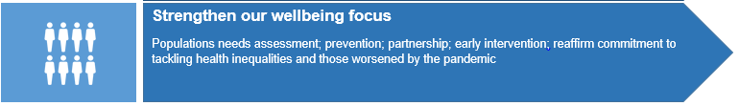
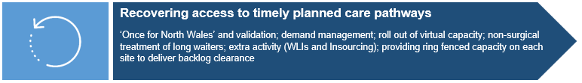
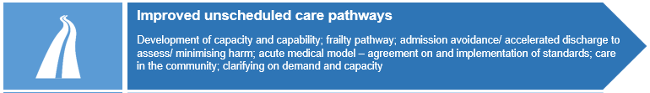
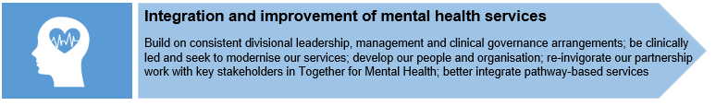

  - Early Recovery Schemes (supported by All Wales Recovery Fund)
A number of schemes have been supported by Welsh Government to support early planned care recovery.
Endoscopy is the biggest single scheme. Our proposal delivers an additional 2,227 sessions over the four quarters of 21/22. This will fully clear the current backlog of over eight week waits taking into account year-on-year growth, and our underlying sustainability gap. This additional capacity will be delivered by a mix of recurrent investment in our endoscopy services and non-recurrent measures. The recurrent consequences of 2021/22 spending in future years will be addressed out of our £30m performance fund monies set out in section 4.2.
The next most significant element is our proposed use of the independent sector. We have a confirmed spend of 600 cases by March 2022, with the potential to add an additional 450 procedures.
Additional funding of £2.9m for diagnostics will clear 4,000 patients waiting over eight weeks for CT, MRI, or ultrasound. Allowing for expected demand growth, this would deliver waiting times for the major modalities of a maximum eight weeks, with reduced waiting times of up to 6 weeks for vital diagnostics.
The balance of our proposal relates to a number of smaller schemes including oncology consultant staffing capacity to manage late presentation due to paused screening programme and drop in unscheduled care referrals. Validation of waiting lists typically delivers reductions in number of patients listed by around 10%. For example, by checking on a patient’s condition and establishing any additional risk factors, establishing the patient’s wishes regarding treatment and through providing good communication with patients, their carer and GP, including patients who may no longer require treatment. At the end of March 180,000 patients were waiting for a follow-up appointment, of those 55,000 people were 100% delayed.
Pathway trackers will provide validation and pathway management support across all planned care aspects, for example within gynaecology services to support patients through their care pathway and to ensure that pathways are being managed in the most appropriate way in line with COVID guidelines. Pre-COVID the default for pathway management was face to face consultation, whereas this resource will allow consultants to review the referrals already in the system and potentially change the mode of management considering the options available.
Validation support is also being provided within therapy services for example podiatry caseload, including patients who require ongoing review. Many of these reviews had been paused resulting in 5000 patients requiring follow up. Validation will ensure that the right capacity is in place to meet patients identified needs. In addition, a Speech and Language (SALT) validation process on the COVID -19 backlog has been introduced to assist to create a sustainable service for the future that includes a graduated pathway of access including virtual and face-to-face appointments, virtual training tools, self-help tools and up to date signposting information. This activity will support a range of patient groups (including head and neck cancer, progressive neurological conditions (e.g. MND, Parkinson’s Disease, MS) and patients presenting with symptoms related to COVID-19 (respiratory dysphagia; post extubation dysphagia, communication difficulties post COVID-19). The full list of Welsh Government approved schemes is as follows:
Scheme | £000’s | £000’s
Women’s directorate pathway trackers | 55
Women’s services to review referrals already and potentially change to virtual activity, See on Symptoms (SOS), advice and guidance | 61
Dermatology validation | 127
Speech and Language Therapy - clinical validation and backlog clearance | 630
Site based pathway trackers with clinical support | 254
Sub total - validation / triage / signposting |  | 1,127
Diagnostics capacity to support waiting list backlog | 2,885
Endoscopy capacity to support waiting list backlog | 8,200
Sub total – diagnostics |  | 11,085
Oncology capacity to support suspected cancer pathway | 1,250
Outsourcing activity within independent sector | 6,480
Subtotal – additional capacity |  | 7,730
Grand total |  | 19,942

  - Key deliverables for 2021/22 (supported by performance fund)
In order to progress the priorities above we will utilise the additional strategic financial support provided by Welsh Government through the £30m performance fund for the next 3 years. The table below shows the areas in which we will invest, along with the expected impact and return from these investments:

Performance fund schemes (subject to approval via robust business cases)

Key to priorities:
COVID-19 response  Strengthen our wellbeing focus  Recovering access to timely planned care  Making effective and sustainable use of resources | Improved unscheduled care pathways  Integration and improvement of mental health services  Transformation for improvement  Effective alignment of our people

Scheme Title | Overview | Addresses Key Priorities above |  |  |  |  |  |  |  | Net Cost £000s  Full Year (FY) /  Part Year Effect (PYE) |  | Key Deliverables / Return on Investment
 |  |  |  |  |  |  |  |  |  | FY | PYE
Attend Anywhere | Supporting virtual hospital outpatient consultations. |  |  |  |  |  |  |  |  | 379 | 379 | - Reduction in the number of patients travelling for services / visiting our premises  - Approach is more efficient in its structure, reduces risk and supports a better patient experience  - Face to face consultations reduced thus achieving the need for social distancing and reducing the risk of COVID-19 spread  - Safer for our staff and patients  - Reduces waiting times  - Based on 4,226 new outpatient appointments / 16,413 follow up appointments for April / May 2021, equating to 25,356 new outpatients / 98,478 follow up appointments for 2021/2022
Continuation of AccuRx digital communication tool in GP practices | Supporting virtual primary care consultations, improved access and communication, and efficient administration. |  |  |  |  |  |  |  |  | 415 | 300 | - Provision of a communication tool between GP and patient to facilitate self-monitoring of chronic conditions  - Screening such as obesity, smoking and asthma, provision of advice remotely, COVID management pre and post appointment direct interface with the GP clinical record  - The improvements above will be measured by:  - Patient satisfaction surveys  - Achievement of access standards  - Reduced DNA rates  - COVID-19 response and recovery  - Enabling care closer to home  - Improving access to safe planned care (freeing up capacity in GP practices for support proactive care)
Planned care recovery schemes | Delivery of agreed ‘early DTC’ planned care recovery schemes (including additional programme management capacity), to include diagnostics, e.g. endoscopy, laminar flow theatres and inpatient T&O bed provision (including relocation of outpatient therapy provision in Wrexham. |  |  |  |  |  |  |  |  | 15,000 | 14,732 | - Capacity planning validation and ‘Once for North Wales’ outpatients  - Improved patient communication and better understanding of demand  - ‘Once for North Wales’ services, value based pathways  - Use of virtual capacity (such as video consultations) and care closer to home  - Non-surgical approaches to long waits  - In sourcing additional capacity to include no over 8 week waits for endoscopy by 31 Mar 22
Development of a cancer-specific and non-cancer elective prehabilitation programme and conservative management pathways / avoidance of secondary care | Prehabilitation delivery within care pathway between listing for surgery and the surgical date maximising fitness prior to treatment.  Pathway redesign with a focus upon conservative management for early onset osteoarthritis and pain, as per Getting It Right First Time best practice pathways. |  |  |  |  |  |  |  |  | 900 | 450 | - Reduced postoperative complications  - Reduced use of critical care  - Reduced length of hospital stay by 2 days  - Reduced readmission rates  - Overall reduction in costs  - Better long term patient health reducing diabetes, hypertension, dementia and recurrence of cancer  - Reduce unnecessary secondary care intervention  - Ensure patients are physically and psychologically prepared for surgery  - Ensure timely access to a service.  - Release c3,000 bed days across BCUHB per year
Eye Care Services: transform eye care pathway | Invest in the pathway redesign to transform the provision of eye care and deliver a sustainable service for the population of North Wales. |  |  |  |  |  |  |  |  | 2,590 | 1,563 | - Maximising eye health and sight retention for the North Wales population  - Achievement of national standards, the eye care measure and access targets  - Elimination of existing backlog  - Significantly improved patient experience and outcomes  - Increased capacity of hospital services optimising the management of patients at risk of irreversible sight loss  - Significant reduction in unnecessary / inappropriate referrals  - Significantly improved operational efficiency and productivity  - Adherence to and consistent application of best practice and guidelines
Urgent Primary Care Centres (UPCC) pathfinder programme | The UPCCs provide additional capacity to support GP practices and Emergency Departments, with patients triaged to the centres both in and out of hours. These pathfinders will be further developed, with the continuation of the Wrexham/Mold Centres (supporting 6 clusters) and the North Denbighshire Centre commencing in Q1, in Rhyl. Development of a pathfinder in the West Area, with the aim that this will be in place in readiness for winter. |  |  |  |  |  |  |  |  | 2,200 | 1,600 | - More timely, efficient care for patients with urgent primary care needs that meet the UPCC inclusion criteria  - More capacity within ED and GP to provide more timely care for other patients with urgent needs that they may not have been able to deal with on the day/within-waiting times  - Ensuring UPCC offers a cost effective service to the Health  - Board and the wider population  - Ensuring that the UPCC clinical capacity is used (appropriately) to full capacity  - Reduced demand for minor illness/injuries treatment in ED  - Improved access in GP practices for those patients with more complex conditions  - Reduced demand for minor illness/injuries treatments in ED  - Improved access in GP practices for those patients with more complex conditions
Single Cancer Pathway | Implement the new Single Cancer Pathway across North Wales To improve Health Board performance against the Single Cancer Pathway measures. |  |  |  |  |  |  |  |  | 2,000 | 1,500 | - Improved performance against the Single Cancer Pathway measures / targets
Stroke Services | Confirm and agree the stroke service model and business case to improve stroke services across North Wales.  Provide a ‘Once for North Wales’ network approach to ensure consistency of clinical outcomes for Early Supported Discharge (ESD) and Specialist Integrated Community In-patient Rehabilitation Services. |  |  |  |  |  |  |  |  | 3,852 | 1,059 | - Provide specialist stroke recovery support at home. This follows the care closer to home strategy of the Health Board  - Reduce time spent in hospital for 37% of current stroke patients (and all the risks to deconditioning involved in prolonged hospital stay) with an intended 12% reduction in bed days  - Improved recovery and increased independence following stroke recovery  - Consequential improvements in performance measures achieved within the first twelve months of full ESD implementation, increased therapy interventions and additional specialist nurses in post - 515 patient discharges home sooner with ESD / reduction of 2,575 bed days
Urology Services | Implement preferred service model for acute urology services. Finalise urology review. Linked to robotic assisted surgery  Implementation of robotic surgery for cancer patients across North Wales. |  |  |  |  |  |  |  |  | 929 | 929 | - Continued delivery of urology services across BCUHB  - Improved recruitment and retention rates  - Dedicated urological specialist teams  - Reduced complication rates  - Improved access for patients  - Retain services and reduce outsourcing  - Provide an equitable service  - Provide increased choice  - Potential to attract activity and income from other health boards  - Reduced recovery time with less pain and quicker return to normal activities  - Provides best practice techniques for patients requiring diagnostics and treatment  - Improved cancer staging  - Decreased cancer waiting times  - Continued delivery of specialist cancer services  - Reduced length of stay in an acute setting: patients are home quicker following safer surgery  - Increased throughput  - Improved utilization of operating department facilities and theatre efficiencies
Home First Bureau (HFB) | Implement Welsh Government guidance by developing a HFB model that is available 08.00 – 20.00 daily that mitigates the risks to vulnerable people, protects resource, maximises the opportunity for active therapeutic input and provides challenge into the discharge pathway for support outside of hospital. |  |  |  |  |  |  |  |  | 1,770 | 1,770 | - Increase in the number of patients on pathway 2 (own home) rather than requiring pathway 3 ((step down facilities)  - Reduction in number of delayed transfers of care  - Increase in assessments of patients post discharge leading to shorter length of stays and releasing beds allowing for an improved patient flow within hospitals  - Positive advantage for the patients who have a delayed transfer of care due to lack of resources to assess  - Increase in patients returning home rather than having to be cared for in a community bed  - Reduce the overall long-term placements in hospital/care home  - Allowing patients to return to the best life possible following their period of illness, think home first
ED workforce | Workforce capacity to meet population demand and deliver Welsh access model. |  |  |  |  |  |  |  |  | 1,200 | 1,200 | - Supports delivery of Welsh access model and access principles and priorities adopted across all sites  - Emergency department access pathway delivery to include a ‘contact first’ system, ‘streaming hub’, and ‘wait & care system’, leading to more efficient navigation of patients
WOD Resource: Strategic Recruitment and Resourcing | Delivery of workforce optimisation programme encouraging reduction in agency spend and efficiency’s. |  |  |  |  |  |  |  |  | 270 | 270 | - Reduce vacancy levels  - Improve retention  - Reduce agency spend  - Increase levels of bank provision
Neurodevelopmental (waiting times - backlog) Recovery of lost activity | Increase access capacity supporting the recovery in waiting times for Neuro-developmental assessments due to the suspension of non-urgent activity between March 2020 and phased restart which commenced in October 2020. |  |  |  |  |  |  |  |  | 1,400 | 1,400 | - Provision of additional ND assessments for lost activity  - Achieve RTT compliant waiting list for ND assessments within the time period of the next 12-24 months
CAMHS training and recruitment | Recruitment of child psychiatry trainees across BCUHB supporting progression to future consultant posts with additional specialist nursing support posts for non-medical prescribing. |  |  |  |  |  |  |  |  |  |  | - Support service continuity  - Ongoing provision of child psychiatry within CAMHS services across BCUHB  - Reduced clinical risk  - Reduced reliance on locums
Primary & Community Care Academy | Further development of the academy to support recruitment, innovation and research in primary & community services.  This will continue to support the delivery of the national model for primary care and contribute to a sustainable service. |  |  |  |  |  |  |  |  | 3,229 | 940 | - Number of professionals choosing to follow a career in primary care  - Retention of staff post training  - Retention of staff post retirement age  - Increase in the number of MDT professionals in primary care  - Recruitment of suitably qualified/experience of staff to vacancies in primary care  - Increase number of extended and advance practice clinicians working within primary and community services  - Practitioners working to the ceiling of their competencies within primary care  - Increased number of professionals both clinical and non-clinical who have received education and training in their relevant fields based on a skills gap analysis  - Increased capacity within primary and community care health settings to meet demand  - Improved communication between primary, community and secondary care and partner agencies
Care Home Quality Nurses | To ensure the care home sector continues to deliver safe effective care to the residents of North Wales. |  |  |  |  |  |  |  |  | 102 | 102 | - Enhancing the quality of life for people with care and support needs  - Delaying and reducing the need for care and support  - Ensuring that people have a positive experience of care  - Safeguarding and protecting from avoidable harm
Continuing Health Care infrastructure | Restructure of the 3 area continuing health care teams – strengthening the new assessment and review functions within CHC. |  |  |  |  |  |  |  |  | 1,138 | 1,138 | - Compliance with CHC legal framework requirements, with assessments and reviews being conducted within required timescales  - Timely decisions on eligibility  - Reduction in dispute cases  - Reduction in retrospective cases  - Reduction of care homes in escalating concerns due to quality assurance concerns  - Reduction in number of complaints with regards to discharge from hospital arrangements and application of correct CHC processes  - Improved patient and family experience  - Improved recruitment into CHC teams  - Clinical outcomes measurable following PDN involvement in care homes e.g. reduction in avoidable HAPU’s, reduction in falls with harm, reduction in WAST attendances and transfers to hospital sites  - Reduction in CHC overdue reviews, reduction in the number of patients receiving additional staffing hours. Patients will be assessed in the right place, right time by expert staff so as to ensure correct eligibility decision first time
Advanced Audiologist / Ear Wax (Primary Care Audiology / pathway redesign) | Extension of the advanced practice scheme and implementation of an audiology led earwax management pathway across BCUHB. |  |  |  |  |  |  |  |  | 800 | 461 | - Evaluation of existing services will continue to ensure a safe, effective and high quality service is delivered.  - Key performance data will be collected, analysed and shared routinely at a whole service level and locally within each practice or and/or locality. This will include:  - Demand and activity  - First point of contact (enabling more than 22,000 people each year to access Audiology)  - Referral rates to ENT and audiology  - Appropriateness of onward referral  - Patients experience  - Primary Care clinician experience

In 2021/22, the part year effect of all the above schemes fully commits the £30m performance funding, whereas in 2022/23 there is a full year effect of £38.44m leading to a potential over commitment of £8.44m. This will be managed down via business cases and 2022/23 planning.
It is critical that the investments set out above, along with the other actions to be identified, are delivered in a timely fashion and have tangible impacts upon the performance of our services.
The table below sets out a high level summary of key performance metrics for 2021/22:
 | Lead Executive  Director | 30 Jun  2021 | 30 Sept 2021 | 31 Dec  2021 | 31 Mar  2022
Number of people waiting over 52 weeks for planned care treatment  (inpatient, outpatient or day case) | Deputy CEO | 43,500 | 43,500 | 48,000 | 43,000
Number of people waiting between 36 and 52 weeks for planned care treatment  (inpatient, outpatient or day case) | Deputy CEO | 55,600 | 55,600 | 51,600 | 44,500
Compliance with the eye care measure | Deputy CEO | 45% | 55% | 70% | 80%
Compliance with the single  cancer pathway | Dir. of Therapies & Health Sciences | 65% | 67.5% | 70% | 72.5%
Number of people waiting over 8 weeks for a diagnostic procedure (excluding endoscopy) | Dir. of Therapies & Health Sciences | 3,600 | 2,000 | 500 | 0
Performance against the mental health measure Part 1a | Dir. of Public Health | 81% | 76.8% | 88.8% | 83.1%
Performance against the mental health measure Part 1b | Dir. of Public Health | 90% | 83.2% | 92.9% | 83.1%
CAMHS – time to assessment | Dir. Of Primary & Comm. Care | 30% | 40% | 50% | 60%
CAMHS – time to treatment | Dir. of Primary & Comm. Care | 25% | 40% | 60% | 60%
Emergency department & MIU compliance against the 4 hour performance target | Deputy CEO | 70% | 73% | 75% | 80%
Ambulance handover delays over 1 hour | Deputy CEO | 1,300 | 1,200 | 1,200 | 1,200
Number of people waiting over 12 hours in our emergency departments | Deputy CEO | 2,200 | 1,700 | 1,000 | 1,000

The above trajectories have been refreshed from our March draft plan to reflect actual performance up to mid-June. Quarterly profiles have been derived from this revised starting position. The quarterly differentials within our March plan continue to apply and are being continually monitored and reviewed with service leads.
The performance metrics above highlight the total number of patients waiting over 52 weeks are expected to remain broadly the same over the year. Section 9 describes the work we are doing in terms of planned care recovery and explains that the shape of the waiting list cohort is changing as we plan to clear pre-pandemic over 52 week waits by the end March 2022 alongside seeing the continued deterioration in our waiting lists due to COVID-19.
Adult mental health operational teams have put strengthened arrangements in place to monitor and review performance, holding services to account.
CAMHS services fall under the Targeted Intervention Framework within which Access (including the Mental Health Measure (MHM) targets) and Workforce are two of the identified workstreams. Based on a demand increase in CAMHS services, both in relation to the number and acuity and complexity of referrals we have updated the CAMHS trajectories. Priority is being given to the development of a robust workforce plan which will support the sustained delivery of the MHM 1a (assessment) and 1b (therapy) targets, in the meantime a tender process is underway for private provision of assessments and therapy to enhance the capacity of the local teams. The figures included in the trajectory assume that teams can continue to access private providers via single tender waivers until a full tender has commenced and that demand does not escalate beyond currently anticipated levels, however the latter is extremely difficult to predict given uncertainties around expected demand.

- COVID-19 and recovery
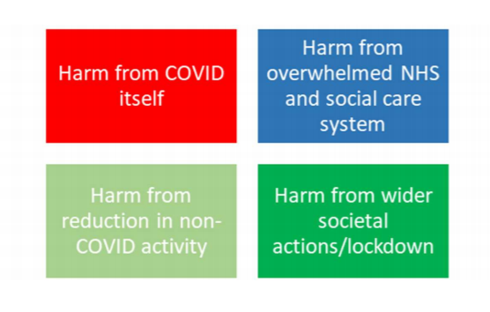
This plan has been developed paying particular attention to the effective management of risk and the avoidance of harm. The potential for harm during the pandemic is particularly heightened and the Health Board has considered the four dimensions of harm arising from COVID-19 as set out here:
Using this framework to view potential harm whilst developing the plan has enabled key priority areas to be identified for immediate action, reflecting the urgency of the current situation. The plan also identifies critical strategic steps, which need to be progressed at the same time in order to drive further improvement in services.
As we continue to see a high prevalence of COVID-19 and the emergence of new variants, we will maintain our health response working with partners to manage the impact on operational capacity across primary, community and acute services. Our planning assumptions for the next 6 months continue to prioritise COVID-19 programmes alongside re-establishing services, capturing and utilising new ways of working and maintaining good practise from lessons learnt throughout the first and second waves of the pandemic.
Test, Trace and Protect continues to play a pivotal role in our overall approach to preventing the transmission of COVID-19 across North Wales, and protecting our population. Our plan focuses upon the delivery of a resilient, sustainable service.

  - Primary and community care recovery
Primary care and community based services face particular challenges in continuing to respond to the requirements of the pandemic whilst also making progress towards recovering full service delivery, including addressing the backlog in supporting patients with chronic conditions.
As part of our COVID-19 response in primary care, we will:
- Continue to work in partnership with GP practices to deliver the COVID-19 vaccination programme, along with community pharmacies and other primary care professionals. Joint plans will be developed to deliver the booster programme which will need to consider the impact on primary care capacity and potentially wider recovery;
- Continue to implement any Welsh Government contract changes to support independent contractors across primary care to protect some elements of our primary and community services. As we develop our plan for recovery during 2021/22, we need to consider how to rebalance funding, workforce and other resources to support the development of primary and community care services to stabilise and then move care closer to home;
- Continue to work in partnership with the national Strategic Programme for Primary Care and ensure resources developed are utilised to support the sector;
- Work with cluster leads and contractors to support the recovery of planned care for patients with chronic conditions;
- Continue to provide support to primary care contractors in the development, roll out and evaluation of new technologies, including telephone triage/consultation and video consultation, and the eConsult and AccuRx digital tools. The evaluation will include a reflection of feedback from patients and clinicians, as well as a review as to how they can support efficient working and improve access, in the context of recent significant increases in demand in GP practices;
- Introduce pathways and resources to provide support for patients presenting with long COVID syndrome in line with national guidance; and
- Work in partnership with secondary care clinicians to support patients waiting for planned care treatment in primary and secondary care services.

  - Vaccination implementation plan
Further to the All Wales National Strategy published on the 11th January, a North Wales Mass Vaccination Implementation Plan (MVIP) was developed to set out the route for delivery of the COVID-19 vaccine programme. The plan was developed as a matter of urgency alongside the implementation of the mass vaccination programme itself.
A North Wales Strategic Vaccine Group was established with multi-agency partners reporting initially to the North Wales Strategic Co-ordination Group (SCG). A tactical delivery group was also established to ensure implementation of the programme. The initial delivery model adopted was as set out below.

Setting | Cohort
Hospital Vaccination Centre (HVC) | Frontline healthcare workers  Care home staff
Mass Vaccination Centre (MVC) | Care home staff  Frontline healthcare workers  Frontline social care workers  Age cohorts
Primary care (GP Surgeries) | Frontline healthcare workers  Frontline social care workers  Care home staff (complete)  Age cohorts (initial focus on over 80s)
Local Vaccination Centre (LVC) Contingency service | Frontline social care workers  Age cohorts  Support for primary care
Care homes | Care home residents
Domiciliary care | All housebound
Community pharmacy | Frontline healthcare workers  Frontline social care workers  Care home staff (mop up)  Age cohorts (initial focus on over 80s)

Implementation of the programme is progressing at pace and the programme has been required to be fluid in order to respond to changing scenarios in relation to priority cohorts, vaccine supply, and changing guidance from the UK Joint Committee on Vaccination and Immunisation (JCVI) in relation to the vaccines. In particular, changes to the recommended eligible groups for the Astra Zeneca (AZ) vaccine have necessitated rapid changes in delivery.
To date, all targets for the vaccine programme in terms of delivery for priority cohorts have been achieved. It is expected that the target for offer of the vaccine to all adults by July will also be achieved, subject to availability of supplies. The table below sets out the progress (as at 29/06/21) in delivery of vaccines by priority cohort.

Priority Group | % Vaccinated 1st dose | % Vaccinated 2nd dose
P1.1 | 106% | 95%
P1.2 | 91% | 82%
P2.1 | 98% | 94%
P2.2 | 98% | 91%
P2.3 | 100% | 97%
P3 | 98% | 95%
P4.1 | 97% | 94%
P4.2 | 96% | 90%
P5 | 95% | 92%
P6 | 89% | 76%
P7 | 90% | 81%
P8 | 88% | 69%
P9 | 89% | 53%
P10.1 | 81% | 14%
P10.2 | 62% | 5%
P10.3 | 71% | 4%

An equality impact assessment was undertaken on commencement of the development work for the vaccination programme. This has been reviewed and an updated action plan put in place to address barriers to participation. Excellent work has been undertaken in conjunction with Local Authority partners including vaccination of homeless people, gypsy and traveller communities, the D/deaf community, and to engage with many community groups to address language and cultural barriers.
As at 30th June 2021, 877,383 vaccine doses had been delivered across all cohorts in North Wales; and a total of 376,206 people have now received both 1st and 2nd dose vaccinations. Immediate next steps for the vaccination programme include:
- Retention of facilities at Deeside leisure centre to ensure successful completion of the initial vaccination cycle;
- Secure new sites to ensure adequate local capacity including the OpTic Centre in St Asaph and Bangor Cathedral;
- Expansion of the network of Local Vaccination Centres in the East;
- Diversifying delivery methods to ensure all groups have access to the vaccine – leaving no-one behind; and
- Developing surge vaccination proposals to support areas of outbreaks and high risk areas and settings, including response to the growing impact of Variants of Concern.

Ongoing issues of concern include:
- The change of recommended age groups for AZ, as referred to above, creating reluctance to take up the vaccine in the younger adult cohorts;
- Vaccine supply concerns due to an increase of 60,000 in the 30-39 age group requiring Pfizer, as well as disruption caused by pressures on the global supply chain; and
- The increasing need to return to ‘business as usual’ within the Health Board, with consequent impact on staff capacity and availability.
Further work will be undertaken pending confirmation of the booster programme by the JVCI which will also link into the Health Board flu vaccine programme for the purposes of planning and delivery.
The programme is currently working up future models for the booster programme, based on the most likely option identified by Welsh Government:
- Cohorts 1-9 and children 12 to 17 (2 doses)
- Cohort 10 in priority order from circa 6 months from 2nd dose.
This equates to circa 700,000 doses needing to be delivered. Outline plans were shared with Welsh Government on 18th June. Key assumptions still outstanding include vaccine type; length of programme; concurrent delivery with flu; start date; vaccine supply chain and potential primary care support.

  - Safe Clean Care Harm Free (SCC-HF)
As part of the Health Board’s response to all health care associated (nosocomial) infections transmission, including concerns around the COVID-19 pandemic, a large-scale change mobilisation programme has been launched supporting the Health Board’s approach of ‘Stronger Together’. SCC-HF utilises the behavioural science methodology defined as COM-B (Capability, Opportunity, and Motivation - Behaviour) with specialist advice and support in applying this technique provided by Public Health Wales (PHW) and their behavioural science unit.
The key aim is to achieve sustainable changes in staff behaviour in order to create a harm free zero tolerance attitude to nosocomial transmission within our health care settings by December 2021 at the latest. This approach equally fully reflects the ‘Safe Clean Care’ principles previously adopted within the Health Board.
In 2018, the Health Board implemented a Safe Clean Care strategy to strengthen infection prevention leadership and assurance. Due to COVID-19 and related factors the original philosophy has been amended and strengthened to now include new priorities and re-branded as Safe Clean Care – Harm Free (SCC-HF).
This sits alongside the learning from all our nosocomial post infection reviews shaping the behavioural change which is needed across the health board to deliver safe clean care harm free. The focus is upon reducing the ‘intention to action gap’, as no one comes to work to do harm.

Safe Clean Care Harm Free (SCC-HF) Programme on a Page
The overall programme has been structured to fully reflect standard project management principles as follows.

  - Coronavirus Co-ordination Unit
The Health Board Coronavirus Co-ordination Unit supports the response to the current phase of the COVID-19 pandemic. Our plan envisages that the Executive Incident Management Team (EIMT) will phase down its activities as community transmission continues to stabilise, alongside the reduction in COVID-19 related hospital admissions and intensive care demand. This will allow a greater focus on ‘business as usual’ as activity begins to re-generate and recovery and reset accelerate. It is well recognised, however that the impact of the pandemic is not entirely predictable and will remain significant throughout the course of the year, and likely for many years to come.
Our current assumption for new cases of COVID-19 during the year 2021/22 is a third wave in the summer months with peak hospital occupancy forecast mid to late August before a further increase in the winter months. Forecast hospital occupancy volumes are based on the most likely scenario (MLS) (issued in March 2021) with timing adjusted locally to move the peak occupancy to later in the year and factor in differing peak times for each of our sites as observed in previous waves.
Revised national modelling work will continue to be reviewed and inform our local planning assumptions. The following chart sets out our current forecast demand for COVID-19 beds, using 30% of MLS in the summer months moving to 100% in the winter period.

We have reviewed our plans for hospital occupancy for quarter 1 and beyond, taking into account the changing situation regarding COVID-19, an expected demand increase on non-COVID unscheduled care and planned care recovery. Expected bed occupancy for acute and community sites (medical and surgical beds) combined is shown in the following chart.

Our plans will continue to be refined as we gain further intelligence in relation to COVID-19 and the anticipated increased prevalence of other infections over the winter months.
Whilst we are seeing the number of admissions to critical care stabilising we are not expecting to see a significant reduction and it will be some time before the vaccine has an impact on critical care.
We have been consistently tracking between the MLS and reasonable worst case scenario (RWC) and based on this, our forecast will continue at 45% of the reasonable worst case for critical care occupancy as shown in the graph below.

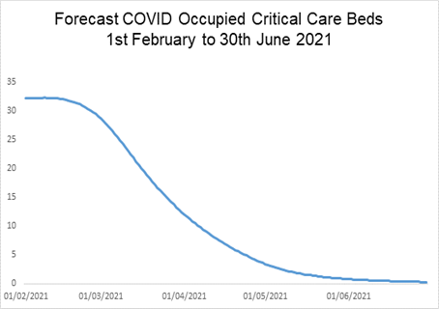
We have considered the information emerging from the above in setting our bed planning for 2021/22. Our current plans involve the following:
- Designated COVID-19 hospital beds in our hospitals, including potential surge beds, are being reviewed in light of revised modelling in 2020/21;
- Our non-designated COVID-19 hospital beds will increase to 1,869, reflecting the change in use for some of the surge capacity previously in place to meet Covid needs;
- The national recommendation for minimum capacity invasive ventilation beds is to maintain 25% above baseline. Revised national capacity analysis suggests a range of 25 to 47 occupancy (31 to 59 beds at 80% occupancy) taking into account higher and lower projections. The funded complement of 36 beds will meet the lower end of this range. Planning is continuing concerning surge capacity staffing to address the higher end should this be required;
- Non-invasive ventilation outside of critical care is being reviewed but in the region of 27 beds may be maintained; and
- Post anaesthetic care units to be in place and by end of quarter 1 there will be 9 PACU beds across North Wales.
In addition to the direct impacts upon hospitals outlined above, it is expected there will be a COVID-19 related additional increase in demand for longer-term care packages and care home placement, despite the greater focus on discharge to recover then assess pathways.
Given the uncertainties regarding the continued impact of COVID-19, contingency plans for our escalation of COVID-19 response and bed capacity will continue into 2021/22. Monitoring and surveillance will continue to ensure that early warning signs of potential need for escalation are acted upon. The EIMT arrangements will be escalated to respond as required in the event of a significant or generalised increase in COVID-19.
The digital legacy of COVID-19 will inform future change and being reflected in the demand and capacity modelling assumptions and local solutions. We will work to optimise this benefit whilst also ensuring that the adoption of digital technology does not unfairly exclude some members of the population, leading to an unintended adverse impact by widening health inequalities.
Whilst the immediate hospital pressures of COVID-19 are expected to reduce, other aspects of demand for services are indicated to rise. This includes attendances at emergency departments, emergency admissions and GP referrals. Our plan sets out how we propose to respond to these changes in demand.
We are also acutely aware of the impact on our workforce of COVID-19 and with that in mind have taken into account a number of factors to ensure the continuity and resilience of our workforce for the coming period.
Initial indications are we need to recruit and deploy additional workforce capacity to build into existing measures such as transitioning the vaccination programme to business as usual and supporting the planned care backlog. With this in mind we are increasing bank hours plus other internal temporary staffing mechanisms in the first part of next year, given the timescales for substantive recruitment and the necessity to keep the workforce flexible until stability is restored in the second half of the year.
We have stable recruitment profiles in terms of students qualifying and taking up established roles across the Health Board and have an international nurse recruitment programme in place which will provide us with 111 nurses. We also expect to see the number of returners fall across the year 2021/22 in line with the COVID-19 related programmes’ activity decreasing, given that the majority of returners have come back to support these programmes. There are initiatives being worked on to try to retain some of this workforce to support the organisation given the different, but ongoing workforce pressures the Health Board will face over the coming year.

Key performance lessons learnt and challenges for 2021/22
2020/21 proved to be a challenging year across the whole health and care sector. Section 1.1 set out some of the Health Board’s key achievements during the year but there are challenges that clearly remain to be addressed, requiring focussed attention in our 2021/22 Plan.

For our primary care contractors, these include:
- Growing demand for primary care services, with a wide range of face to face and digital access routes now in place;
- Significant pressures on workforce, including those arising from COVID-19;
- A decrease in capacity of some key services due to infection prevention and control (IPC) requirements, such as phlebotomy;
- Support for patients those with one or more chronic diseases, and addressing the backlog of care; and
- Support for patients whilst they wait for their planned care treatments from secondary care services.
Whilst significant improvements have been achieved in adult mental health provision in relation to access to mental health assessment and treatment within 28 days of referral, there remain challenges in achieving the commencement of psychological therapy within 26 weeks of referral. Current delivery is improving, however we only achieve a performance of 45% against a target of 80%, resulting in longer waiting times for our patients.

Child and adolescent mental health services (CAMHS) continue to see challenges relating to reduced capacity within the teams and reduced physical capacity within CAMHS accommodation due to social distancing requirements. As a result, performance against access standards has been impacted. Current delivery is 17% against a target of 80% for children and young people commencing therapeutic interventions within 28 days of assessment and only 38% receive an assessment within 28 days of referral. Improvement in access to services is required to meet Welsh Government assessment targets and there is a need to further develop early intervention post diagnostic services.
The graphs below summarise the performance challenges facing our CAMHS service in meeting the requirements of the Mental Health Measure:
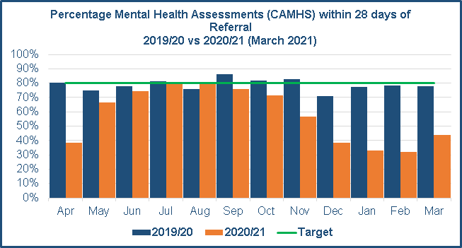
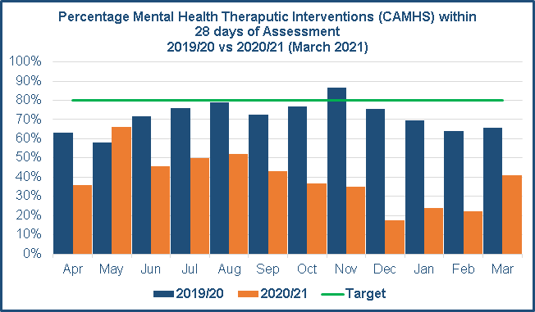
Following the first lockdown in March 2020 there was a significant reduction in both the number of attendances and ambulance conveyances to the three Emergency Departments across North Wales. Activity has fluctuated over the past 12 months with increases and decreases broadly corresponding to changes in COVID-19 lockdown restrictions, however, the total number of attendances across the Health Board for 2020/21 has remained below pre-COVID-19 levels. We expect that the further lifting of restrictions will result in an increase in attendances to pre COVID-19 levels.
Our unscheduled plan in section 11 reflects the work being undertaken to address this anticipated increase and includes actions to improve flow in our secondary care Emergency Departments and the transformation of emergency and urgent care services, with initiatives such as Phone First, 111, the use of alternative pathways and the development of Urgent Primary Care Centres.
Initially, the COVID-19 pandemic had a significant impact upon the number of urgent suspected cancer referrals from our General Practices, falling to 37% of the 2019 monthly average in April 2020. However, after a joint communications campaign by the Health Board and Welsh Government, referral rates quickly increased and were at pre-pandemic levels again by July 2020. From 1st January 2021 cancer performance measures moved to the Suspected Cancer Pathway and our plans for 2021/22 include a number of initiatives to support delivery of the new measure.
During the first few months of the pandemic the number of patients waiting over 8 weeks for a diagnostic test rose to a peak of just over 15,700 by September 2020. Capacity was significantly reduced due to the need to work safely with COVID-19 and non-COVID-19 patients and as such the focus was on seeing patients on an urgent or urgent suspected cancer pathway. At the end of March 2021 the number of patients waiting over 8 weeks had been reduced to just over 8,000. The highest number of delays are in Endoscopy, Cardiology and Radiology and reducing the delays in these areas is a focus of the Annual Plan for 2021/22.
At the end of March 2020, there were 11,798 patients waiting over 36 weeks, and 3,113 patients waiting over 52 weeks on a Referral to Treatment pathway. At the end of March 2021, the number of patients waiting 36 weeks was 51,433 and the number waiting over 52 weeks was 43,423. Comparing these figures highlights the impact of the pandemic on planned care services and the scale of the task to address the backlog of long waiting patients.

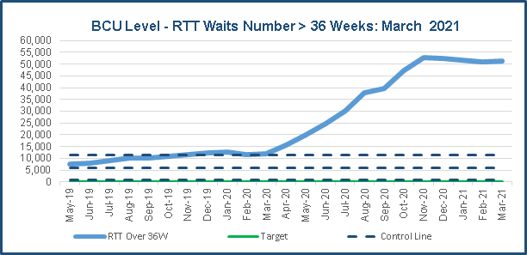
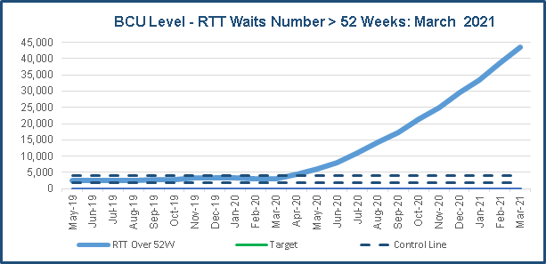
A new model of waiting list management, alongside that of the Referral to Treatment model was introduced to ensure the safe management of the growing numbers and length of wait for patients on our waiting lists. In line with other Health Boards in Wales, the Health Board implemented the Royal College of Surgeons risk stratification methodology to manage the waiting list on the basis of level of risk of harm to patients.
In addition, the Health Board adopted new ways of working such as virtual clinics and consultations for our patients. This was complemented by the introduction of Consultant Connect to enable GP’s to access consultant advice and thus reduce the need to refer patients into secondary care.
The pandemic has been a catalyst for modernising the outpatient follow up model which will release capacity to help reduce the waiting times for patients. Where appropriate and clinically safe to do so, patients are now discharged from follow up with either a ‘See on Symptom’ (SoS) or a ‘Patient Initiated Follow Up’ (PIFU). This allows patients to come back into the system without having to see their GP for a re-referral.

Key integrated planning assumptions – COVID-19 workforce and finances

Developing this plan in the context of the pandemic has been complex given the uncertainty with regard to resource availability, particularly workforce and the overall impact and implications of COVID-19. This has required a number of assumptions to be made in support of our planning activity. Given the importance of these assumptions, it is critical that they are documented so that they can be understood when assessing the delivery aspects of this Plan. We have identified five workforce assumptions:
- The sickness absence rate forecast for the year ahead has factored in the potential effects of Long COVID by identifying staff with open COVID-19 related sickness record in excess of 28 days, which currently stands at around 41 staff. Whilst we expect to see staff sickness reduce across the year, we expect this to be a gradual reduction primarily driven by a major reduction in COVID-19 sickness as the vaccination programme works through the cohorts and staff are vaccinated. This assumption is reflected across the other sickness lines reported in the minimum data sets (MDS) which support this Plan;
- With regard to vaccination, our workforce delivery model is underpinned by robust plans which provide assurance that through working in partnership we can achieve, if not exceed, our expectations in this most critical and challenging of COVID-19 programmes. Our plans detail the additional workforce to extend and expand the vaccination programme to support the delivery of cohorts P5-P10. The current plans are based upon primary care teams delivering approximately 60% of doses with the remaining 40% delivered through Mass Vaccination Centres (MVCs) and Local Vaccination Centres (LVCs). Staffing numbers are flat lined until July and then decrease in line with the plan, with contingency for provision of a business as usual service being required across Q3 and Q4 of 2021/22;
- The Test Trace Protect staffing has been flat lined across the year as it is estimated that this service will stay in place across 2021/22;
- For other COVID-19 related Whole Time Equivalents (WTEs) we have factored in a reduction at the rate of 10% each month from April 2021 onwards. This is based on looking at the areas currently supporting the COVID-19 programmes and estimating when they might start to stand down or reduce their services. This will of course be subject to review based on experience against the forecasting;
- We expect the cleaning standards put in place as part of the COVID-19 programme to stay in effect for the whole 2021/22 and as such have flat lined the WTEs associated with this work;
The financial assumptions associated with the COVID-19 operational response are:
- The Test, Trace and Protect and vaccination programmes remain active throughout the year;
- Specific financial arrangements for continuing healthcare and funded nursing care will continue for quarter 1 and be funded by Welsh Government;
- Other COVID-19 costs will continue until mid-August and be funded by Welsh Government.
Clearly, there remains a degree of uncertainty about these assumptions and they will be subject to review within the quarter 1 period with appropriate amendments being made to the plan in year.
Welsh Government planning guidance confirms that known COVID-19 costs will be funded through an additional resource allocation. Therefore, the financial assumption in the plan is that COVID-19 costs as shown in the table below and estimated at £115.7m, will be funded in the same way.
Funding of COVID | Pay  £’000 | Non Pay £’000 | Total  £’000
Covid funding - Stability funding | 10,894 | 31,299 | 42,193
Covid Funding – PPE |  | 6,544 | 6,544
National Programme - Cleaning Standards | 2,297 | 192 | 2,489
National Programme – Care Homes |  | 1,250 | 1,250
National Programme – Vaccination Programme | 7,722 | 4,961 | 12,683
National Programme – Testing | 2,374 | 429 | 2,803
National Programme - Tracing | 2,806 | 10,721 | 13,527
National Programme - Protect | 77 |  | 77
Surge Funding | 122 | 1,340 | 1,462
Impact on Non Delivery of Savings |  | 32,663 | 32,663
Total COVID-19 | 26,292 | 89,399 | 115,691

The Welsh Government has indicated that there will be an allocation of £170m to NHS Wales to cover some of the costs associated with COVID-19 during the first half of the financial year. The Health Board expected share of this allocation is £38.4m.
It is anticipated that the plan will be subject to quarterly review and amendment, as national and local assumptions around the impact of COVID-19 and recovery of planned care activity are updated.

Strengthen our wellbeing focus
The following table sets out the key deliverables for this element of our plan, with further supporting information below:
Key Deliverables 2021/22
- Continue to work to reduce the prevalence of smoking and associated harms;
- Progress our smoke free site activity by ensuring increased access to support services and the progression of the mental health smoke free action plan;
- Establish initiatives to be implemented as part of the homelessness/poverty programme, (in partnership with housing associations, third sector and local authorities);
- Implement the infant feeding project, by increasing training rates and improve activity rates;
- Develop and commence a children’s tier 3 obesity service, and establish and implement referral mechanisms;
- Establish a Physical Literacy North Wales programme;
- Continue to focus on our vaccination planning, ensuring our general vaccination programmes are on track, alongside the additional COVID-19 vaccination planning for winter 2021/22;
- Continue to deliver the regional Test, Trace and Protect programme with a range of partners;
- Progress in partnership the inverse care law programme which seeks to identify opportunities for early intervention actions and targeted services.
- Implement the neurodevelopment model of working, improving access to services for children to meet Welsh Government assessment targets and further develop early intervention post diagnostic services;

The Health Board remains committed to a population health focus including strengthening wellbeing actions and tackling inequalities. The harm caused to the population of North Wales by COVID-19 is and will potentially be significant for some time to come and we recognise that the pandemic has hit our poorest communities the hardest.

Whilst overall health in North Wales is good, we still have long-standing health challenges across the region. These include our high smoking rates, issues relating to obesity (all ages), and limited physical activity levels. In recent years we have successfully progressed our work on the ‘lifestyle bundle’, to support healthy choices, promote self-care, ensure a focus on prevention and resilience work, and to support clinical pathway work (e.g. diabetes). We have placed a particular focus on setting up the required services, and therefore in 2021/22 we will start turning our attention to the wider challenges for individuals and communities.

From a population health perspective, we will continue to build on our activities and our plans for improving the health and well-being of the population in North Wales. We will do so in partnership through whole system working – building on our work with localities, local authorities, universities and the Third Sector.

During the year ahead we will focus on health protection activities, prevention and early intervention, and improving health and well-being. We will specifically continue to place a significant focus on ensuring a good start in life though a focus on the health of the child.

This work will be underpinned by the refresh of our population needs assessment and well-being assessments. This work will be undertaken in partnership across the region, and will ensure a renewed focus on understanding needs at the local and regional level to support our planning work.

Our priorities are set out below.
  - Health Protection - we will:
- Continue to focus on our vaccination planning, building on the significant progress made to date to continue to improve the reach of this programme throughout our population, communities and priority groups. This will include ensuring our general vaccination programmes are on track, alongside the additional COVID-19 vaccination planning for winter 2021;
- Deliver the regional Test, Trace and Protect programme with a range of partners.
  - Prevention and early intervention - we will:
Further progress the key programmes which support life style choices, health improvement and the management of long term conditions through the continuation of the ‘Prevention and Early Years’ and ‘Healthy Weight: Healthy Wales’ funding. These include:
- Increasing take up of smoking cessation services through creating greater accessibility;
- Improving infant feeding rates through targeted support for families;
- Reducing childhood and adult obesity through further developing pathways and capacity;
- The creation of a network of physical literacy experts to support individuals, children and families,
- Progress the inverse care law programme through mapping current services and needs, and identifying areas of opportunity – through a partnership approach’; and
- Develop a framework on mental well-being (all ages), to support the wide range of public health mental health activities underway across the Health Board. This will support the targeted intervention activity, but more importantly support the emerging additional needs emerging post COVID-19.

  - Improving health and wellbeing - we will:
- Progress our work on the inverse care law, with a focus on our locality working, building upon our social prescribing activity across the region;
- Work to meet the needs of those most at risk through our strategic partnerships - the Alcohol Harm Reduction Strategy, the North Wales Suicide and Self Harm Reduction Strategy, and our Immunisation Strategy;
- Further grow the Well North Wales programme of work by expanding our food poverty and homelessness initiatives;
- Link with our community experts and third sector colleagues to help extend our reach to all vulnerable and hard to reach groups, alongside the work of our newly appointed BAME outreach officer;
- Explore and agree the next steps for our arts and health programme; and
- Support the Sports North Wales programme – to ensure the focus on meeting needs and promoting physical activity.

Recovering access to timely planned care pathways
Recovering access to timely planned care requires a whole system response with primary and secondary care clinicians working together to support patients both waiting for and having access to care in primary and secondary care settings.
Our ambition is to provide state of the art facilities, ultimately staffed by local NHS teams using modern equipment within timescales that will reduce harm to patients and enable robust and sustainable NHS services for our population of North Wales.
A strategic outline case for the development of Diagnostic & Treatment Centres was approved by the Board in May which envisioned highly technologically advanced equipment and a blended workforce that will provide much needed services, giving patients with cancer and vague symptoms the ability to have earlier assessment, diagnostics and treatment which would be regarded as world class. The exploration of options to expedite delivery of this much needed capacity to reduce harm associated with increases in demand associated with Covid delays has now commenced. This will enable the Health Board to achieve our goal of addressing the risk of harm associated with long waits and deliver a new and sustainable planned care service for our North Wales population. This could be achieved within around two years, compared to a more traditional process that could take us five to six years to achieve the same goal.
The approach would enable us to reduce harm and provide health and socio-economic benefits to our population. The proposal is to utilise funding that leaves a positive legacy and wholly owned and run facilities by the Health Board.
The key benefit of a revenue and partnership route for example is that it improves the efficiency of the unit - providing state of the art facilities procured cost effectively and equipment that has a guaranteed efficiency as part of the contract, with fast turnaround of equipment and minimal “downtime”, delivering high levels of efficiency.
In terms of workforce availability, a partnership approach may afford additional employment flexibilities. The proposed service model is also likely to be inherently more attractive offering rotational opportunities, clinical skills development, and multi professional education and training.
The model will enable decoupling of unscheduled and scheduled care, reducing cancellations on the day of surgery, providing capacity to better manage unplanned access via Emergency Departments. It will provide an improved environment for patients and our workforce who would be able to focus and deliver a new model of surgical delivery free from the disruption of the district general hospital pressures and in turn attract further research and development opportunities.
This proposal will ensure that all appropriate patients currently being treated outside of North Wales can be repatriated to receive healthcare closer to home.
The following table sets out the key deliverables for more immediate planned care recovery, with further supporting information below:
Key Deliverables 2021/22
- Deliver the ‘Six Point Recovery Plan’ that builds on improving business process and improving care through reducing waiting times across North Wales;
- Support the continuation of AccuRx on line platform for GP Practices, to promote efficient access to general medical services;
- Increase dental treatment provision, moving towards delivering the pre-COVID-19 activity levels throughout 2021/22;
- Work with cluster leads to develop and implement proposals to address primary care backlog, particularly in relation to supporting patients with one or more chronic conditions;
- Continue to develop the Primary & Community Care Academy to support the delivery of the Primary Care Model for Wales, with a focus on innovation, research, new ways of working and recruitment;
- Deliver an earwax management programme to improve access for patients;
- Build upon the ‘Once for North Wales’ approach, using our hospital capacity flexibly to meet the needs of the whole population. Implement consistent approaches to demand management and patient validation through our outpatient transformation programme and end to end pathway redesign;
- Implement ‘Attend Anywhere’ and online consultations (eConsult) to improve access. Improve the triage process to ensure the most appropriate clinician to meet a patient’s need;
- Develop a diagnostic and treatment centre model to transform planned care service delivery;
- Ensure patients are physically and psychologically prepared for surgery, improving patient outcomes and reducing length of stay, for example through prehabilitation;
- Deliver a sustainable eye care service for the population of North Wales based on the work to support the introduction of the national eye care measures;
- Deliver improvement against the single cancer pathway, enabling delivery of the national target of 75% of all patients achieving the single cancer pathway;
- Implement urology services redesign enabling work to progress on service developments including the introduction of robotic surgery in North Wales;
- The implementation of the national Maternity Strategy for Wales (2019-2024) to include the transformation of maternity services and working in partnership with early years services;
- Transformation of gynaecology and specialist services. Review of free standing midwifery led units across the North Wales community, review of access to water birth services and the refurbishment of acute maternity units across all sites in addition to birth choices

The Health Board and primary care contractors continued to deliver essential services throughout 2020/21 in line with Welsh Government requirements. The impact of COVID-19 however meant that there were detrimental impacts upon other services, which were curtailed, including significant aspects of planned care with associated risk and harm. Ensuring that planned care services can expand to address the risks identified and begin to reduce the backlog of patients waiting is a key priority for our plan.
  - COVID-19 impact on planned care
The backlog of treatment for patients which arose before and also due to COVID-19 continues to increase. The following table sets out the number of patients waiting over 36 and 52 weeks by treatment stage as at 10th June 2021:
 | Waiting list backlog
 | Waiting between  36 – 51 weeks | Waiting over  52 weeks
Stage 1 – outpatients | 7,978 | 25,326
Stage 2 / 3 – diagnostics | 2,043 | 5,102
Stage 4 –inpatients and day-cases* | 1,674 | 12,577
Total | 11,695 | 43,005
Note: stage 1 outpatients / stage 2 and 3 diagnostics / stage 4 inpatients & day cases.
The table illustrates the significant number of patients whose treatment is currently paused. This number continues to rise, with a forecast, based on current activity levels of 50,000 over 52 week waiters by the end of 2021/22. The distribution of waiters across sites is generally comparable, with the “Once for North Wales” approach starting to level the inequalities of wait for high-risk patients, however the variable patterns of long waiting patients across our hospital sites continue.
In addition to the reduction of activity levels as a result of the pandemic, there was a marked reduction in referrals. This has begun to recover, and there remains an expectation of increasing demand during 2021/22, as set out below:
- Demand for urgent suspected cancer referrals has returned to pre-COVID-19 levels but cumulatively the total demand is around 4000 cases lower in December 2020 than it was at the same point the previous year;
- The number of cancer patients starting treatment in 2020/21 was 3648, which is set to increase to 4233 during 2021/22; and
- Screening services reopened during December and the demand via these services will be carefully monitored to assess volume, type and stage of demand filtering. The temporary cessation of screening services has contributed to the reduction in newly diagnosed cancers generally and in early stage diagnoses in particular.
It expected that referrals will increase, compared with 2020/21 levels, particularly in quarters 3 and 4, as more patients present. In relation to cancer services this has been estimated as follows:
- Urgent cancer outpatient referrals are expected to rise from 23,091 in 2020/21 to above pre-COVID levels at an estimated 27,500; and
- Urgent non-cancer outpatient referrals are expected to rise from 27,308 in 2020/21 to closer to pre-COVID levels at an estimated 31,926.
As the year progresses the number of referrals will be monitored against these assumed levels, to understand the ongoing impact of the pandemic, alongside the transformation work.
Single Cancer Pathway performance (62 day) which currently stands at 68% compliance, has a planned action to increase to 75% to meet the national standard. This will be supported by the delivery of the suspected cancer pathway programme including the implementation of diagnostic pathways for each area; lung and endoscopy.
  - 2021/22 planning assumptions
In order to support our planning assumptions we have considered the predicted demand for COVID-19 total occupied beds and COVID-19 occupied critical care beds to the end of June 2021.
In March, our planning assumptions were that Q1 (2021/22) is likely to be similar to Q4 (2020/21) in terms of admission and occupancy, noting that there are many unknowns around vaccine and the new variant. Actual activity has been incorporated into Welsh Government minimum dataset for quarter 1 (MDS) and assumptions will be regularly updated and tested.
This aligns with our financial assumption that COVID-19 response will continue to be the main clinical and operational priority in the first six months of the year, with planned care activity stepping up in the second half of the year. Welsh Government has provided strategic support of up to £90m over the next three years to be used to improve performance across North Wales in both planned and unscheduled care. This will be critical to addressing the backlogs and the Health Board’s ambition is to design and implement a clinical model which will provide improvements to performance, patient outcomes and efficiency.
  - Our recovery programme
The Health Board has set out a six-point recovery plan to re-start, treat and transform planned care, for increasing activity and reducing waiting times.
The plan provides an integrated solution to addressing the immediate challenges whilst identifying the critical need for longer term transformation solutions through the Diagnostic & Treatment Centre approach and changing to a value based pathway approach.
The re-start programme deals with cohorts 1 &2 which have been defined as patients waiting over 52 weeks as of March 2020 and cohort 2, patients waiting from 1st April 2020 to 4th April 2021.
The organisation has compiled an action plan and trajectory to recover cohort 1 by March 2022 and commencing cohort 2 clearance over the next two-three years. This activity is regarded as additional to the core plan and will be undertaken via additional clinical sessions, outsourcing and insourcing. There is also a commitment to pursue an option of modular theatres and wards to support orthopaedic elective activity and preventing disruption from further unscheduled care pressures.
The plan is summarised below:
2020/21 | 2021/22 to 2024/25 | 2025
Six point plan established  Enablers:  - Diagnostics  - Workforce  - Digital  - Performance fund  - Effectiveness | Strategic outline case March 2021, outline and full business cases June 2022.  - Point 1 – capacity planning validation and Once for North Wales outpatients.  - Point 2 – patient communication and understanding demand.  - Point 3 – Once for North Wales services, value based pathways.  - Point 4 – use virtual capacity and care closer to home.  - Point 5 – non surgical approaches to long waits.  - Point 6 – In sourcing and extra capacity. | Handover to Diagnostic and Treatment Centre or Centres  Ambulatory care model  In patient capacity

The need to implement an early recovery programme is part of the ‘Six Point Recovery Plan’ and comprises the following activities:
- Capacity planning, validation and “Once for North Wales” outpatients. An example of the “Once for North Wales” approach is eye care pathway patients (especially cataract patients) where one waiting list will identify priority patients who will be transferred to alternative sites for treatment. Resources will be utilised in a prioritised way no matter where in North Wales the patient lives;
- Patient communication and understanding demand;
- Value based pathways;
- Use of virtual capacity and care closer to home; and
- Insourcing and extra capacity.
A summary of the short-term actions which will form the 2021/2022 plan is set out below:
Substantive staff continue to deliver P1-P2 activity both stage 1 and stage 4 | Using ‘Once for North Wales’ Approach | Insourcing model to be used for long waiters stage 1 and stage 4 | Theatres to be used each weekend across North Wales to facilitate the insourcing activity, day-case only (8 theatres) | Modular theatre and wards x3 either centrally located or on each site for insourcing activity treating P4 long waiters | Capacity plan/activity schedule to understand timelines for backlog and clearance (starting in quarter 1)
Note: P1 highest clinical priority / P4 lower priority.

Within the recovery plan, there are three fundamental elements:

The first element is to improve productivity back to the pre-COVID activity of 2019/20. This will provide extra activity that is currently unavailable and provide planned care to the previous baseline level, from which further productivity improvements can be made.
The second element builds on this productivity by reviewing pathways and moving to the value based system. It will also address some of the underlying demand and capacity shortfalls that have been historically identified such as the requirement for further orthopaedic capacity. The six-point plan describes improving patient outcomes and provides alternatives to current treatments, such as the move towards more “office based decisions”, earlier interventions and diagnostics by primary care.
As we address the capacity gaps through new ways of working, we also need to address the substantial numbers of long waiters. The backlog has two components:
- The backlog from 2019-20 of 14,911 over 36 week waits, of which 3,113 were over 52 weeks. (This highlights the shortfalls in capacity at that time.);
- The COVID-19 pandemic then paused all routine elective activity, which led to an increased backlog of 43,255 over 52 week waiters;
Giving a total backlog position of 46,338 (3,113+43,255), across all stages.
To be able to understand the scale and implications of the backlog, the table below lists the key specialties and the amount of extra sessions required (based on the 2019/20 activity outturn) to clear the backlogs.
Speciality | Stage 4 sessions required to reduce back log below 36 weeks (across BCU) | Stage 4 sessions required to reduce back log below 52 weeks (across BCU)
General surgery | 1448 | 1239
Urology | 418 | 371
Trauma and orthopaedics | 2576 | 2340
ENT | 642 | 611
Ophthalmology | 328 | 348
Max/Fax | 215 | 191
Total | 5627 | 5100

Understanding the amount of sessions required, allows some indicative timelines to be forecast. Whilst some of the specialties listed above could recover in 6-9 months, general surgery and orthopaedics would need to be measured in years. This timeline is indicative and assumes that the service is not subject to further disruption due to further COVID-19 outbreaks or winter pressures.

The table below summarises the anticipated phasing of key elements of the short-term recovery plan:
Scheme | Commencing from: | Speciality | In-patient | Day Case | OPD
Insourcing for risk stratified P4 | Q1 | Orthopaedic  Urology  Ophthalmology  General surgery  Women’s services  Maxillofacial services | Yes  Yes  Yes  Yes  Yes  N/A | Yes  Yes  Yes  Yes  Yes  Yes | Yes  Yes  Yes  Yes  Yes  Yes
Additional Clinical Activity sessions (ACSs) For P2-3 risk stratified patients | Q1 | All specialties | Yes | Yes | Yes
Modular theatres and ward | Q2 | Orthopaedics’ | Yes | Yes | N/A
Prehabilitation | Q1 | All cancer Specialties | Yes (Critical care)
DGM to run insourcing work | Q1 | Orthopaedic  Urology  Ophthalmology  General surgery  Women’s services  Maxillofacial services
Working towards delivering Endoscopy standards | Q2 | Endoscopy |  | Yes | Yes
Working towards delivering Single Cancer Pathway | Q2 | All cancer vague symptom specialties | Yes | Yes | Yes

Key Performance Indicators
Our summary of activity plans for 21/22 for the following:
- First outpatient appointments (OPA) (face to face) - 110, 523;
- First OPA - virtual (not face to face) – 37,408;
- Follow up OPA – (face to face) - 266, 710;
- Follow up OPA - virtual (not face to face) – 214, 207;
- Number of inpatient procedures - 23, 186;
- Number of day case procedures - 27,810.

  - Primary Care Recovery
In response to the ongoing challenges in primary care, the following priorities have been identified:
- Ensure primary care involvement and engagement in the transformation of clinical pathways, to support recovery and address the planned care backlog across the whole system, reviewing the impact of any operational changes and provider capacity. This will be supported by the Transformation Office of the Health Board.
- Provide additional funding to ensure continued use of the AccuRx and eConsult online platforms in GP practices, supporting improved access and demand management for general medical services. This was a specific request from primary care providers who are experiencing a number of workload efficiencies as a result;
- Encourage GP practices and community pharmacies to report their escalation levels, with Area teams taking proactive action to provide support where necessary;
- Establish a Dental Training Academy, hosting a training unit, General Dental Services (GDS) contractor and Community Dental Services (CDS), with a focus on increasing access to dental services in the west area of the health board. The tendering process for providers is currently underway, and it is envisaged that this will provide valuable additional activity within the West of BCUHB, as well as generating an advanced practice dental workforce within BCUHB;
- Increase the number of core urgent access sessions commissioned from general dental practices, providing an additional 250 to 700 patient appointments dependent on complexity of treatment needed. Proposals have been developed to commission further urgent and non-urgent sessions, as well as additional orthodontic activity;
- Complete the Pharmacy Needs Assessment by October 2021, providing a reference for the planning and commissioning of future community pharmacy outlets and services;
- Support the training of additional independent prescribers in community pharmacies; and
- Continue to develop the integrated eye care programme and Ophthalmology Diagnostic and Treatment Centre (ODTC) model of care, optimising care closer to home and improving access to services.
In relation specifically to chronic conditions, diagnostics and screening, proposals are now being advanced with our clusters, recognising that schemes need to be put in place over the summer months. In order to progress this work dedicated project management support will be identified and in the interim, independent contractors are being encouraged to adopt a triaged approach where chronic disease management backlogs exist, to ensure that those with highest need are prioritised.
Furthermore, the priorities listed below will be delivered to support the whole recovery and ongoing development.

  - Primary care sustainability - we will:
- Develop our Primary and Community Care Academy, including the establishment of the Dental Academy with a dental training unit and provision of dental services, an additional training hub to further support advanced practice training in primary care, the further development of the Physician Associates programme and piloting of ‘Project Flex’, a flexible approach to GP recruitment.

  - Primary care premises – we will:
- Continue to engage at a national level with Welsh Government to review all primary care facilities, in order to develop a robust primary care estates strategy to support the delivery of new ways of working, growing demand and care closer to home.

  - Health and social care locality working – we will:
- Ensure that integrated localities continue to develop and deliver their priorities for 2021/22, which include:
  - effective delivery of the COVID-19 vaccination programme;
  - integrated mental health and well-being; and
  - chronic disease management, in particular diabetes and lifestyle choices.
- Further develop MDT working and advanced health practitioners working in primary care settings;
  - developing the community resource teams;
  - support for care homes; and
  - frailty pathway development.
  - HMP Berwyn
There has been a very different year at HMP Berwyn during 2020 / 2021 as a result of the impact of COVID-19 on the prison population. As a result of this our priorities for 2021/ 2022 are:
- To offer an enhanced mental health and learning disability provision specifically addressing difficulties around recruitment and retention of specialist staff; and
- Enhancing capacity to address the unacceptable long wait for routine dental care for residents at HMP Berwyn.
We will review our primary care and substance misuse services structure to ensure we continue to deliver a responsive and fully integrated health and wellbeing service at HMP Berwyn. This will include a retendering process for our in hours and out of hours GP service subject to Board and Welsh Government approval.

  - Specialist Services
Specialist services for the population of North Wales are predominately provided from Health Board and NHS England providers with a small number of services provided from NHS Wales’s providers.
The Health Board is a provider for a number of regional and national specialist services including Artificial Limb and Appliance Services, cardiac services, CAMHS, cochlear and bone anchored hearing aids, Inherited bleeding disorders, neonatal intensive care, mental health services - forensic psychiatry, positron emission tomography (PET) services and renal services.
As a provider the Health Board has a number of models in place for delivering specialist services across the region, these include care provision locally in a single site or a combination of 2 or 3 hospital sites.
Similarly, there are a number of models in place for specialist services provision from NHS England providers, with care being provided both at the specialist provider facility and as outreach into Health Board facilities. The outreach services and models vary across specialist services and the hospital sites. They include models where the specialist services are described as provider at or provider with the Health Board. The model of care is of particular importance in relation to the governance arrangements in place.
We are working with Welsh Health Specialist Services Team (WHSST) to develop a joint work plan and services strategies to ensure progress is being made in terms of equity, quality, sustainability and repatriation.
This work will inform planned and unscheduled care pathways, the wider Health Board recovery and also shape our clinical services plan. Areas of focus in 2021/22 include CAMHS, cardiology, plastic surgery, paediatrics, neurology and acquired brain injury.

Improved unscheduled care pathways
The following table sets out the key deliverables for this element of our plan, with further supporting information below:
Key Deliverables 2021/22
- Further develop the pathfinder Urgent Primary Care Centres, supporting an integrated model of unscheduled care and integrating these with the ‘contact first’ development and roll out of 111;
- Develop the Home First Bureau approach to support timely discharges , by consolidating our resources including continuing healthcare, frailty pathway, discharge to recover and assess, and community resource teams;
- Deliver support to care homes with a focus on quality assurance;
- Implement the recommendations in the Welsh Government document ‘Rehabilitation: A Framework for Continuity and Recovery 2020-21’ to support the ongoing needs of COVID-19 patients;
- Complete a systematic review of Emergency Departments, working with local emergency admitting teams to map the current availability of services and identifying gaps to be addressed to develop and deliver improvement to the service;
- Implement Emergency Department access and patient flow (using the Welsh Access Model/ Emergency Department Quality and Delivery Framework / Frailty and Acute Medical Model);
- Implement the stroke service model strategic case enabling work to progress on strategic service development, strengthening acute stroke services across each of the three district general hospital sites;
- Develop a clear set of pathways for certain conditions to support the direct referral of patients to the most appropriate setting and provide a more seamless and efficient service to improve patient flow;
- Implement Same Day Emergency Care (SDEC) improving service delivery through standardisation and resulting in improved patient outcomes;
- Developing the unscheduled care hub, 111 service / contact first, reducing Emergency Department unnecessary attendances

Responding to urgent and emergency care needs across the whole range of Health Board services has been a considerable challenge throughout the pandemic, however significant innovation and change has been delivered during this period through the re-design of patient pathways. We will build on these COVID-19 pathway improvements, including the speed at which change has occurred and use this learning to help shape and review our unscheduled care patient pathways going forwards.
We will need to ensure a robust approach to addressing the ongoing demands of the pandemic and the winter pressure challenges ahead, with appropriate surge plans in place as required, dependant on the ever-changing environment of the pandemic.

As set out in Section 4, it is expected that the demands placed upon hospital inpatient services as a result of COVID-19 will reduce as we move into 2021/22. Whilst this is positive in terms of reducing this specific demand within our hospitals, there are indications that demand arising from other causes will increase during the year. This has been assessed against the 2018/19 baseline data and we expect a significant increase in emergency admissions from 58,085 in 2020/21 to 95,337 in 2021/22 based on the following assumptions:
- April - June 2021 5% increase (taking account of any reduction in restrictions and acuity of patients), Royal College of Emergency Medicine also suggests 5% uplift;
- July – August 2021 15% increase – this predicts circa 17-18,000 attendances over these months (taking account of social economic elements and expected increase in surgical emergencies);
- September – October 2021 - 5% increase (expecting admission rates to increase due to the above);
- November 2021 onwards – 100% comparison to 2018/19 (expecting usual seasonal conditions (for example respiratory, frailty etc.).
Given the significant performance challenges which the Health Board currently faces and the demand projections above, the need to undertake a fundamental re-assessment of key aspects of our unscheduled care delivery is clear.
The following elements have been identified as key to tackling the problems associated with unscheduled care:
- Leadership and trust across systems;
- Ability to align goals across health and social care; and
- A whole system approach.
In 2020/21, short term funding was directed to hospital front door (SDEC) and early supported discharge (D2RA = Discharge to Recover and Assess). Short term funding has not enabled sustained change or enabled a thorough assessment of the impact of the interventions. Longer term or invest to save funding will depend on being able to demonstrate good patient and system outcomes.
There are some areas of excellent practice in the Health Board, however the Board have recognised the need to sustain, embed and disseminate this practice. Clinical teams must be supported to describe a vision for their services and to define what good looks like for staff and patients.
It is recognised that the Health Board requires support to address these challenges. We are able to map the unscheduled care system in a number of ways in order to break it down into manageable parts whilst not losing sight of the connectivity that is required to make services work effectively together. To this end the Health Board has joined forces with the National Collaborative Commissioning Unit (NCCU) who are supporting the Board and its social care partners to deliver a comprehensive improvement programme designed to improve timely and appropriate access to urgent and emergency care services. Translated into practical terms the Health Board has committed to ensuring that our citizens are helped and supported to access the right care, delivered by the right professional in the right place, first time and every time.
The Health Board will maximise the opportunity to secure recurring central funding through the NCCU commissioner which will allow us to continue our support to programmes such as Same Day Emergency Care (SDEC), Welsh Access Model (WAM), Contact First linked to 111 rollout and Discharge to Recover and Assess (D2RA). Recurring funding will provide an opportunity to break the cycle of ‘stop/start’ of initiatives and allow teams to apply a truly transformational approach to modernising and improving the services and care we provide.
We describe an effective service as a service that should lead to good patient outcomes and good patient and staff experience in each of the domains depicted below.
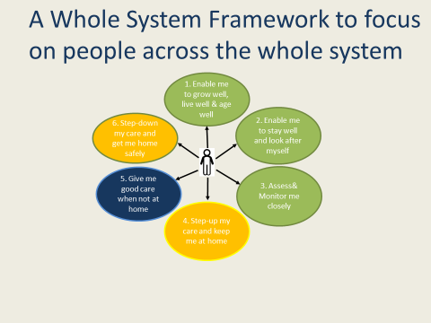
In order to address this deficit in our service delivery, the NCCU has agreed to work with us to frame a programme and provide ongoing support and challenge over the next 18-24 months to help the clinical and managerial teams own the developments and embed the change.
The NCCU team have met with a range of staff and teams as well as stakeholders across the health and social care system to review local urgent and emergency care plans and have developed an outline plan. The NCCU team’s expertise will support clinical and managerial leadership teams to develop, implement and embed change and deliver improvements that focus on reducing harm, improving quality of care to ensure better outcomes for patient and better staff experience.
The following diagram illustrates the emerging plan setting out 4 key workstreams and supporting illustrative projects for the urgent and emergency care transformation programme of work
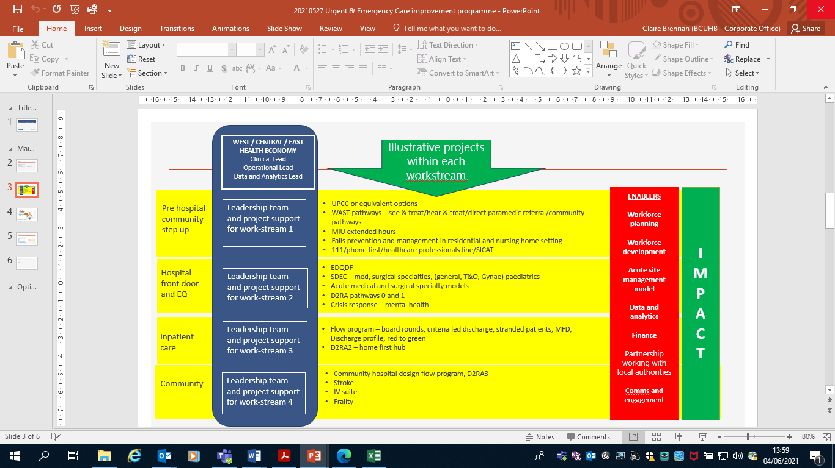
Welsh Government has provided strategic support of up to £90m over the next three years to be used to improve performance across North Wales and this will be allocated across planned and unscheduled care. We will use this funding to drive forward the most critical aspects of service change that will support service transformation and enhanced performance in unscheduled and planned care.
In addition to the work described above, we are taking a system and pathway approach to ensure we can deliver seamless care across all services. This will include developments such as ‘Contact First’ and the implementation of 111, working alongside our GP Out of Hours service. We saw a significant drop in attendances and admissions across our Emergency Departments during the first phase of the pandemic in spring 2020 and we will endeavour to implement lessons learned, alongside these new services to maintain this position by continuing to educate and support the North Wales population and offering seamless services with primary care and other unscheduled initiatives.
In primary care, we will:
- Further develop the Urgent Primary Care Centre (UPCC) pathfinders as part of a national programme of innovation to develop alternative urgent care services. The UPCCs provide additional capacity to support GP practices and Emergency Departments, with patients triaged to the centres both in and out of hours. These pathfinders will include the continuation of the Wrexham/Mold Centres (supporting 6 clusters) and the North Denbighshire Centre commencing in Quarter 1, in Rhyl; and
- Continue to be a key partner to the national strategic programme, sharing the ongoing learning and evaluation; contributing to the Welsh Government priority to transform unscheduled care. Furthermore, a business case will explore the development of a UPCC pathfinder in the West Area, with the aim that this will be in place in readiness for winter, integrating these with the ‘phone first’ development and roll out of 111.

Integration and improvement of mental health services

The following table sets out the key deliverables for this element of our plan, with further supporting information below:
Key Deliverables 2021/22
- Development of clear patient centred pathways of care and crisis services;
- Recruit and train psychiatrists in CAMHS supporting progression to future consultant posts, along with additional specialist nurses;
- Implement a number of support mechanisms including investing in the roll out of the mental health practitioner model and community connector role to localities in order to improve primary care resilience;
- Design clear and well-defined model of inpatient care that meets the population demand and draws upon the highest quality evidence base, improving our holistic approach to care;
- Introduce a programme of work across the mental health division to review long length of stay and delayed transfers of care, promoting safe and timely discharge of patients to the appropriate setting;
- Implement ward accreditation to improve the fundamentals of care and leadership, improving service delivery and outcomes for patients and their families, with all wards achieving a bronze award or above;
- Implement a programme to integrate health systems and develop digital health initiatives;
- Enhance leadership within mental health, developing a sustainable workforce plan including training to support service redesign;
- Further develop the delivery of clinically led safe and effective services, aligned with the Dementia Strategy;
- Work with area teams and local authorities to provide support to care homes through a team based approach;
- Implement an agreed model for early intervention in psychosis;
- Deliver clinically led, safe and effective services for mothers and babies and commission two specialist services placements.

The need to deliver continued improvement in our mental health services for people of all ages is a key priority for the Health Board and is reflected clearly in the targeted intervention framework published by Welsh Government. Recent events have seen the emergence of increasing mental health and wellbeing needs arising from the pandemic, which require an effective and timely response.
During the pandemic, there was a reduction in referrals to some services and it is envisaged that this will be reversed in 2021/22. Our planning assumption is for demand to return to pre COVID-19 levels, which will see an increase from 11,400 to 14,645 referrals under section 1a of the Mental Health Measure. Similarly, crises referrals are expected to reflect activity prior to COVID-19, with the usual fluctuations in seasonal demand.
We have commenced work to transform our mental health services and to ensure long-term sustainable delivery. This work is taking into consideration the various services in place, which are experiencing pressure including that felt by helplines and crisis response during the pandemic.
Within the Welsh Government budget for 2021/22, recurrent funding for mental health services was secured which is to be targeted towards delivering improvements in specific priority areas in the Together for Mental Health Delivery Plan 2019-2022 which was refreshed in October 2020 in light of COVID-19. The Mental Health & Learning Disability (MH&LD) Division, in collaboration with CAMHS services, submitted proposals against this recurrent funding which will embed quality improvement approaches in service re-design and also address the impact of COVID-19 on the current demand and models of service.
The specific proposals related to:
Eating Disorders – CAMHS and Adults services | £971,505
Perinatal services | £156,000
Increased assess to psychological services – CAMHS and Adult services | £652,450
Specialist CAMHS | £813,000
Crisis Care/Out of Hours Provision (all ages) | £903,000

During 2021/22, there will be a particular focus to ensure that the MHLD Division is working more closely across the organisation and with partners. We will re-invigorate our partnership work through engaging with key stakeholders in keeping with the Together for Mental Health Strategy and ensure our clinicians lead and support the work we need to do to modernise our services.
In terms of the £12m capability strategic support allocated by Welsh Government, the Health Board has allocated £6.7m in 2021/22 to improve mental health and learning disability services (including CAMHS) and progress the mental health strategy in partnership.

The strategic support resource which has been made available to mental health services will support delivery of engagement and transformation programmes across the Health Board, which are clearly aligned to the following 5 main strategic drivers:

- Supports the requirements outlined within the Welsh Government Targeted Intervention Framework.
- Aligns plans against the 4 strategic objectives of the Division, namely:
  - Delivery of safe and effective services in partnership;
  - Stronger and aligned management and governance;
  - Engagement with staff, users and stakeholders;
  - Review of capacity and capability.
- Addresses the 4 ministerial priorities for mental health namely:
  - Tier 0/1 prevention;
  - Crisis prevention/response;
  - Suicide prevention/response;
  - CAMHS.
- Learning from COVID-19 – applying lessons learned from the impact of the COVID-19 outbreak, and its management, on health and social care in Wales
- Together for Mental Health Delivery Plan 2019/22 key priority areas:
  - Eating disorders;
  - CAMHS;
  - Further development of perinatal mental health services;
  - Increased access to psychological services (all ages);
  - Crisis care/out of hours provision (all ages);
  - Early intervention in psychosis.
Other priorities identified for improvement include:
- Divisional management and clinical governance arrangements are being strengthened to ensure delivery of safe services;
- We will continue to strive to achieve the national target of 90% provision of valid care and treatment plans;
- We are committed to appointing a substantive service leader to support the improvement of psychological therapies;
- CAMHS transformation and Improvement; to develop a workforce plan and sustainable workforce, service model and enhanced care pathways, including:
  - Crisis; improved care for children and young people in crisis so they are treated in the right place at the right time and as close to home as possible;
  - A better offer for the most vulnerable children and young people, making it easier for them to access the support that they need when, and where they need it; and
  - Multi-agency children’s transformation work developing integrated pathways of care.
- Within CAMHS there are also specific requirements to address long waiting lists for access to services. In response to this resource has been identified from the planned care performance fund which will enable the following actions:
  - By 30 June 21, gain external support to increase therapy capacity and assessments for therapy;
  - Development and implementation of a Children and Young People (CYP) workforce plan during Q1 to Q2 including considering new roles and the recruitment of psychiatry trainees in each Area and appoint twelve family wellbeing practitioners to posts across the teams;
  - Embrace and fully utilise ‘Attend Anywhere’ and ensure that this is utilised by all teams (supported by effective performance information processes) during Q1;
  - Modernise our working practices, utilising new IT hardware for staff during Q1 and Q2; and
  - Improve our offer with the development of a CYP website to promote the service and support recruitment (Q2).
The current proposals for the allocation of £6.7m strategic support funding is as follows:
 |  |  | Mental Health for Adults and Children
Description | Cost £m | Key deliverables
Older Persons Crisis Care | 0.5 | Improved and earlier response for older adults with severe and enduring mental health and those with dementia crisis;  Improved patient experience;  Reduction in unplanned/avoidable admissions/attendances at Emergency Departments;  Reduction in DTOCs in acute hospital setting.
Eating Disorders | 0.5 | Local specialist assessment and treatment of individuals (in line with NICE 2017 guidance);  Individuals will be offered a range of psychological interventions;  Specialist treatment which will ensure safe and effective management of psychological, physical and social aspects of their eating disorder;  Collaboration with CAMHS to ensure seamless transition and integration of care across services for young people requiring adult services.
ICAN Primary Care | 1.7 | Direct and rapid access to wider ranging support in primary care;  Tier 0 support by introducing ICAN connectors and ICAN community hubs.
Medicines Management | 0.6 | Improved patient compliance and education with current medication
Occupational Therapy | 0.4 | Increased therapy leadership across the Division to assist in reviewing and improving patient flow between primary and secondary care;  Improved MDT working with a focus on recovery and overcoming barriers that prevent patients doing activities that matter to them and also discharge support.
Perinatal | 0.2 | Reduce mental illness in the mother and improve the mother-infant relationship;  Regular and on-going training to allied mental health and primary care colleagues to improve understanding and knowledge of perinatal mental health.
Early Intervention in Psychosis | 0.3 | Reduce treatment delays at the onset of psychosis;  Promotion of recovery;  Reduction in episodes of relapse.
Psychiatric liaison | 0.3 | Timely response;  Reduction in delays in Emergency Departments for mental health assessment;  Signposting to alternative support services.
PMO Support Function | 0.2 | Project support for managing and reporting against all initiatives across the Division;  Dedicated support to clinicians for tracking outcomes.
Consultant Therapist | 0.1 | Support key strategic priorities of the Division, strengthening leadership and cross divisional working and assisting in reviewing and improving patient flow between primary and secondary care. Lead pathway development to further meet the ambition for integrated service improvement and transformation through a holistic approach to care and improved multi-disciplinary ways of working.
CAMHs transition and joint working | 0.8 | Effective and timely transition arrangements that support young people into adult services;  The needs of young people and their families met;  Effective joint working arrangements between adult mental health, CAMHS and local authority professionals.
Integrated autism service | 0.7 | Timely assessment for individuals;  Dedicated support to individuals and their families.
Joint commissioning pot with AISBs | 0.3 | Joint approach to commissioning health and wellbeing services for local population via community localities.
Wellness, Work and Us | 0.2 | Staff will feel valued empowered individuals;  Reduced stigma around mental health;  Dedicated staff wellness areas to support wellbeing of our staff.
Total | 6.7
Resources for mental health services will continue to be ring-fenced in 2021/22. Compliance of individual organisations with the ring fencing requirement is monitored on an annual basis by Welsh Government. Additional funding has been allocated to the ring fenced mental health allocation for the Health Board as a cost growth uplift. This will contribute to funding unavoidable cost growth in mental health services and includes funding to cover the first 1% of 2021/22 pay awards.

Enablers

We have identified a number of priorities and enablers, which are critical to the success of our plan, which are described in brief below. They also support the programme of development, which is key to demonstrating progress against the Targeted Intervention Framework, which will be a key measure of success in 2021/22. The table below identifies the targeted intervention domains and the relevant enablers:
Targeted intervention domains | Our core key priorities and enablers supporting targeted intervention delivery;
Mental Health (adults and children) | - Transformation for improvement  - Integration and improvement of mental Health Services
Strategy, planning and performance | - Transformation for improvement  - Stronger governance  - Making effective and sustainable use of our resources.  - Aligning our people
Leadership (including governance, transformation and culture) | - Transformation for improvement  - Enabled by effective alignment of our people  - Stronger governance
Engagement (patients, public, staff and partners) | - Transformation for improvement  - Strengthening our population health focus

Organisational development
We have committed to embark on a programme of work which aims to align each and every member of the organisation behind the goal of “One NHS organisation”, working with our partners and citizens to deliver co-ordinated seamless care or service for individuals. Our approach to this ambitious work programme, titled ‘Mewn Undod Mae Nerth’ (Stronger Together), is framed by evidence-based research, which will allow us to join the threads across the organisation and the system that facilitate the conditions for and are associated with high performance through an engaged and motivated workforce, committed to delivering the healthcare goals for North Wales.

Our plan is informed by previous commissioned reviews and by ‘A Healthier Wales’ and is driven by the quadruple aims described therein:

- Improved population health and wellbeing;
- Better quality and more accessible health and social care services;
- Higher value health and social care; and
- A motivated and sustainable health and social care workforce.

The overarching approach we are adopting will enable the organisation to discover its current capability and answer the question: “What do we need to do as an organisation and system of care to succeed in the achievement of our purpose and goals?” Its design aims to integrate all existing quality, performance and productive service change and development activities currently taking place within the organisation.

We are working in partnership with our people so that the solutions to the problems we face are co-produced with people who work across the organisation and understand the challenges. Our approach will continue to be inclusive to ensure that those who contribute are truly representative of our people and that wider cultural aspects are taken into account.

Applying the framework for large-scale change, we are using the model of discover, design, delivery to inform our strategic organisational development route map. The model is shown in the diagram below:

12.1. Mewn Undod Mae Nerth (Stronger Together)

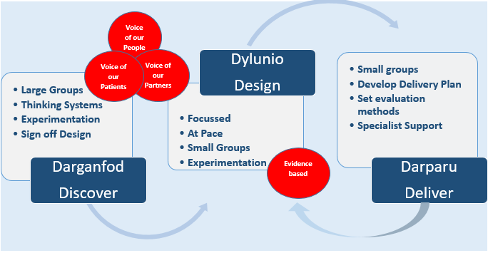

This work is consistent with and aligned to the seven themes within ’A Healthier Wales: Our Workforce Strategy for Health and Social Care’. As we move through the phases this will inform our contribution to the refresh of the Regional Workforce Board - workforce strategy, together with the updating of the Health Board’s own workforce strategy.

The approach is positioned as organisation-wide and systematic, engaging our workforce, our partners and fundamentally our patients in the pursuit of a strategic organisation and system development route map for the Health Board. It is aligned to our vision for transformation as detailed earlier in this plan.

The goals and outcome measures have been established for the first phase, and work commissioned began in earnest at the beginning of April 2021.

We are clear on the route map and are well into our Discovery Phase “Let’s Talk”. The graphic below illustrates the timeline and key milestones. As described above we are working with our people and partners to deliver this work and in doing so are not only bringing together change agents from across the organisation to support delivery, but also building the capacity, capability and confidence to be self-sustaining in our focus on organisational health and the significant alignment with improved care, outcomes and experience. Our aim is to create a “social movement” across all groups and levels supporting our organisational and individual recovery and at the same time setting the tone for the culture we want to see, hear, feel and experience.

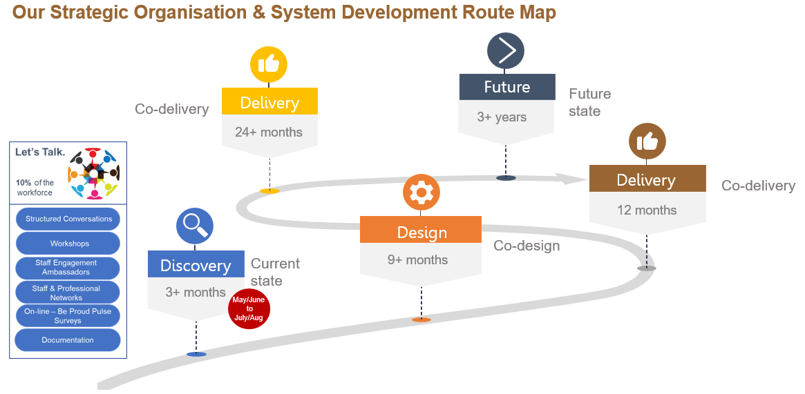

We have been clear from the start that this is championed and led from the Board through our organisation to our citizens and as such, the delivery structure is led by the Chief Executive. The structure below outlines the primary delivery structure.

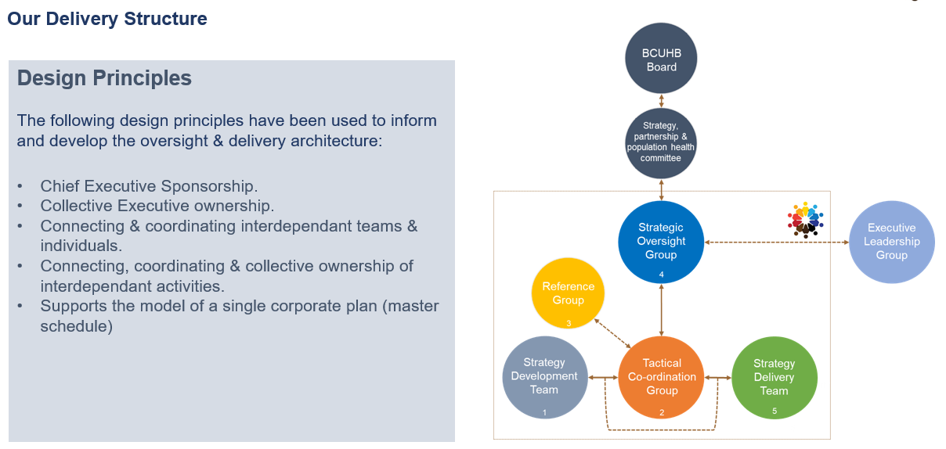

In addition, and critically, we have built the development of our Board Development Programme on these design principles and are clear that the learning and feedback from our Discovery work will inform the further design of the programme in quarter 3.

In addition, the measures of success and maturity set out across the maturity matrices developed across the 4 domains will be supplemented with the learning and feedback from the Discovery work, with the evidence, outcomes and reference groups being formed by people from across our organisation, partners and population. The longer-term aim is that Mewn Undod Mae Nerth evolves from a title for this piece of work to a way of working. This will clearly take longer to achieve but the work over the course of this year, building on the experiences of the last, will be fundamental to the strength of the foundations underpinning sustainable change and improvement.

Key Deliverables 2021/22
- Establish and mobilise the 3 year strategic organisational and system development route map – Stronger Together;
- Develop an Organisational and Leadership Development Strategy 2022 – 2025
- Align the Board and Senior Leadership development as part of this Strategy

Stronger governance
The Health Board continued to strengthen its system of integrated governance in the latter part of 2020/21 and will build on this progress to embed change in 2021/22. This will ensure that systems are in place to keep our public and staff safe and informed. Performance and accountability remain key priorities alongside co-worker involvement and engagement in decision making through social partnerships. This will support the transfer of innovations into practice, working with partners.
The Health Board will oversee the delivery of the Targeted Intervention Improvement Plan through the use of maturity matrices for the four improvement domains which are:
- Mental Health Management;
- Strategy Planning & Performance;
- Leadership; and
- Engagement.
The Board has appointed Executive Directors to lead each of the domains, supported by a link Independent Member in order to effectively draw upon the breadth of skills and knowledge within the Board.
Executive Directors have developed maturity matrices within their domains that have been co-ordinated through the Targeted Intervention Steering Group and agreed by the Board. In May 2021 the Board agreed baseline reference points to reflect the current position in each domain, against which progress will be measured.
Progress will be tracked bi-monthly by the Health Board with a formal review of progress every 6 months as part of the standard reporting arrangements to the Board. Improvement expectations for the second six-month period will be set in November 2021. Actions to deliver the improvements required are contained throughout this plan and supporting programme level action plans.
The delivery of actions contained in this plan will be evidenced via the Board’s performance report, with scrutiny and challenge provided by both the Finance and Performance Committee and the Quality, Safety and Experience Committee. Accountability for the delivery of actions will be clearly articulated across the organisation with service areas held to account for their performance through the monthly accountability review process.
Progress in the reducing risks set out in the Board assurance framework will be subject to review by the Health Board and its committees throughout the year as the actions set out in the plan are delivered.
Finally, following feedback from the Board, work has commenced to develop a new Integrated Quality and Performance Report (IQPR). This new report and underpinning processes will align with the Health Board’s Performance and Accountability Framework and will seek to ensure that overall there is a more robust process of assessment and reporting in place.
Assessment against the key outcomes will be a standing agenda item at the quarterly divisional executive accountability reviews and local accountability reviews. The information collated will also be used to contribute to our assessment against the Targeted Intervention Framework.

Making effective and sustainable use of resources
The Health Board’s current availability and use of resources presents a number of challenges, including but not limited to, high premium rate pay expenditure, the quality and volume of estate and delivery of effective demand and capacity planning.

Against this baseline position, the pandemic has placed significant additional strain upon all of the Health Board’s resources, most notably our people and estate. These demands are expected to continue during the period of this plan and therefore focused action is required to ensure that we make the best use of resources in the short, medium and long term. Our approach to this challenge is set out below:

- We will adopt a new approach to building our financial plan, including the development of a three year financial and service strategy;
- We will implement a workforce optimisation plan;
- Applying principles of value based healthcare, we will identify unwarranted variation ensuring transparency about why realistic decisions based on available resources are required. We will develop strategies to overcome barriers to implementation of change and build capacity and capability to implement the best available research evidence into effective action; and
- Decarbonisation – we have a number of capital investments which support our commitment to improve energy efficiency and reduce reliance on fossil fuels. We will continue to increase our sustainable energy generation and reduce our carbon footprint. This will include the provision of the new electrical service vehicles and the associated charging points.

Workforce
The following table sets out the key deliverables for this element of our plan, with further supporting information below:
Key Deliverables 2021/22
- Deploy a clinically led service and workforce review programme to support effective planning, commissioning and deployment of our workforce across the Health Board, in order to ensure focussed and efficient recruitment, integration of new roles and optimisation of resources;
- Continue to execute improvements in staff safety, support, wellbeing and resilience, in order to improve attendance, retention and contribution;
- Develop and deploy an integrated multi professional education structure, together with the further enhancements in strategic educational collaboration, to support establishing the Health Board as a learning organisation and an employer of choice;
- Develop and deploy a programme of work, as part of the strategic equality plan, to support the organisation in meeting its Socio-Economic duty;
- Refresh the workforce strategy 2019 – 2022 for the period 2022 – 2025.
Building on the work undertaken through the pandemic we will focus on improving the connectivity between service design and delivery and workforce shape and supply. This will include clinically led reviews of existing delivery models, which will then inform the workforce plan and ensure the skill mix is correct for service delivery and sustainability leading to proactive workforce commissioning and placement opportunities across primary, community and secondary care settings, whilst continuing to develop a longer-term approach to agile and flexible working.
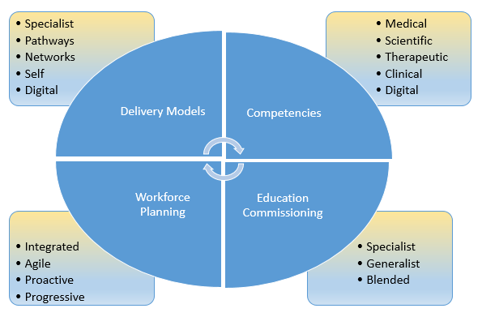

Recruitment and, importantly, retention of staff will continue to be managed through collaboration between operational and clinical teams, clinical corporate teams and workforce teams. Informed and supported by both workforce and service reviews and education improvement plans, we will ensure that we have systems in place to make it easier for managers to plan, recruit and on board staff in an efficient way. Where this means agreement to proleptic appointment i.e. proactive in anticipation of turnover to facilitate handover and reduce gaps requiring interim support and/or increasing establishment to reduce high cost temporary workers, we will work in partnership to facilitate this - reducing barriers and realising benefits.
Clearly the scale of the challenge in terms of delivery of additional activity as part of our unscheduled and planned care improvement is significant. Set against a context of post pandemic fatigue and the assumptions built into our planning to date, we are clear that resourcing delivery of our plan will be multi-faceted.
Supported by the work undertaken nationally with regard to flexibility of rates etc. and the clarity of clinical direction our plans for 2021-22 are based upon pump priming additional capacity and capability through:
- In house additional clinical activity – a blended approach of flexibility of sessions, additional sessions and utilising extended/blended roles. Opportunities for further enhancement of additional roles ,e.g. physician associates, to support sustainability of ongoing services is one, but important, key to our planning and delivery;
- Insourcing additional capacity and capability – flexible service delivery supplemented by dedicated and protected capacity and capability focussed on elective care. Particular examples include diagnostic services/endoscopy;
- Outsourced additional capacity and capability – whilst recognising the balance required, these services will be deployed to support those clinical specialities where the volumes are high and risk of harm is significant; and
- Further development of enhanced services around the patient out of hospital – increasing our bed base is not the solution either to provision of improved care and outcomes or in terms of attracting and retaining high quality staff. Using the challenges as a catalyst for changing our models from traditional to contemporary/evidence based and patient centred is essential and is factored into the assumptions in our workforce planning.
These measures will provide the necessary capacity and capability to deliver the care critical for our communities now, whilst supporting the development of improved pathways of care across our footprint, optimising our architecture and driven by improved outcomes.
Consistent with our responsibilities under the quadruple aims as well as our Socio Economic Duty we will continue to work with partners as part of the foundational economy challenge fund project - “Solving challenges with recruitment, retention and training of North Wales’ social care and health workers.”
In addition, the development of an integrated multi professional education structure, together with the further enhancement of strategic educational collaboration will be an essential element in achieving our vision for transformation. Building on the work done to date to work towards establishing the Health Board’s reputation as a learning organisation, committed to education and continuous learning and innovation and as a result an employer of choice.

Developing a career escalator will support us in illuminating the opportunities across the organisation as well as enabling us to better spot and nurture talent within the organisation. Creating the right environment and establishing the required infrastructure for our leaders to excel will be central to our talent and succession planning programmes.
We will continue to ensure that our staff continue to be supported with safe working conditions and that we are providing additional support for wellbeing both physical and psychological. Below is a diagram that outlines the levels of support that are in place to support staff and some of the broad types of provision that enable that support offer.
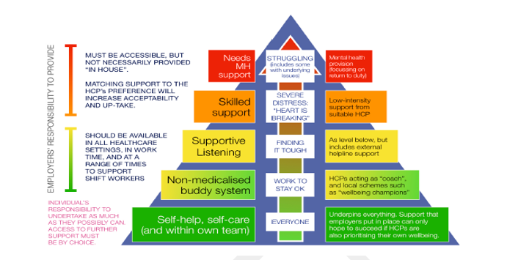
Building on the services delivered through our occupational health and wellbeing service and the staff support and wellbeing services deployed during the pandemic, we will continue to build capacity through the organisation to better support our staff within their teams. Using a model that enables staff to support themselves with signposting through to access specialist support and advice we will work with partners to build upon the resilience demonstrated through the last 12 months.

12.5. Capital
The Health Board has access to a number of sources of capital including its discretionary allocation, the all Wales major capital programme, specific all Wales programmes, charitable funds and the Intermediate Care Fund (ICF). Taken together these form the capital programme.
The Welsh Government has confirmed that the Health Board’s discretionary allocation for 2021/22 is £14.421m. After making provision for slippage and brought forward commitments from 2020/21, together with a 15% over-commitment to allow for potential in-year slippage, we will develop a discretionary capital programme of circa £15.7m total value.
Welsh Government have confirmed the establishment of a “Funding Programme for Targeted Improvements in the NHS Estate in Wales”. The programme is focused upon improvements with respect to estate infrastructure, mental health, decarbonisation and fire safety. Following a review of the bids received the national Estates Advisory Board have supported additional funding for the Health Board of £4.597m.
National programmes are established for radiotherapy and imaging. The Health Board’s bids total £5.075m. 2021/22 is expected to be the final year of the ICF funding programme and investment is focused upon those schemes that have commenced.
Finally, the Health Board regularly submits business cases to Welsh Government in order to access the all Wales major capital programme resource and the draft capital resource limit for 2021/22 indicates the following:
Capital projects with approved funding | £million
Primary Care - Central Denbighshire Ruthin | 1.586
North Denbighshire - Royal Alex – Fees | 0.181
Holyhead - Substance Misuse | 0.376
Shotton - Substance Misuse | 0.454
PAS System | 0.169
Emergency Dept. Systems | 0.335
ICF Funding | 0.793
Wrexham - Fees to OBC | 1.397
Approved funding | 5.291

For 2021/22, the following priorities have been identified for the programme to focus on:
- Mitigating risk (and addressing compliance)
- Supporting patient safety
- Recovering (and learning) from COVID-19
- Service recovery (planned care)
The following draft programme has been developed for the total anticipated resource:
Discretionary and national programmes | £million
Estates  - Risk and compliance  - Patient safety  - Recovering (and learning) from COVID-19  - Service recovery  - Accommodation  - Decarbonisation | 3.261  2.946  3.131  3.810  0.500  1.430
Medical devices replacement programme | 2.188
Imaging and radiotherapy national Programmes | 5.075
Informatics | 3.123
All Wales capital projects approved funding | 5.291
 | 30.755

Financial plan
- Financial context
The Health Board has historically been unable to meet the challenge of living within the resources allocated by Welsh Government, despite significant savings being delivered. Utilising the deficit cover funding provided by Welsh Government in 2020/21 allowed the delivery of a small surplus and the revised plan for 2021/22 will deliver a break-even position after confirmation of additional funding to offset the impact of non-delivered savings during the COVID-19 pandemic.
This performance is illustrated in the following table:
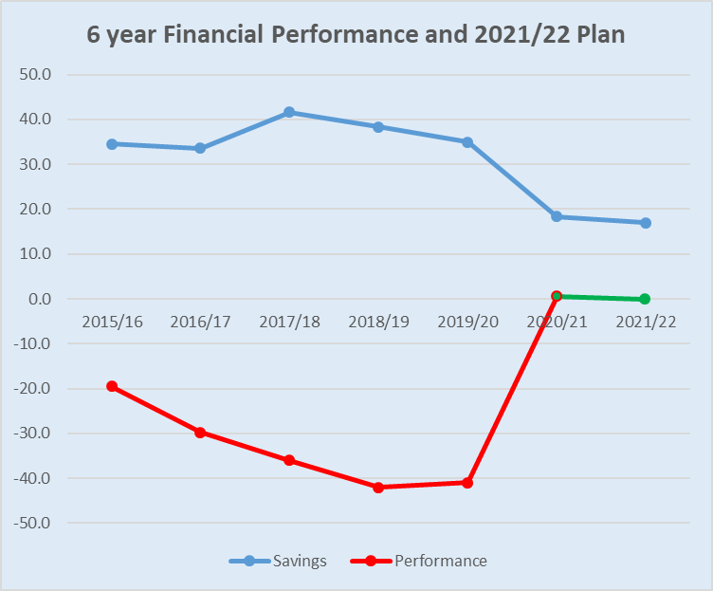
Looking forward to 2021/22, the Health Board continues to face a significant underlying deficit position, which is a consequence of our residual infrastructure and delivery inefficiencies from 2019/20 combined with the impact of the non-delivery of recurrent savings in 2020/21, as shown below:
 | £000
Residual Infrastructure and Delivery Inefficiencies | (42,500)
Impact of COVID on our Savings Delivery Plan for 2020-21 | (32,663)
Underlying deficit carried forward | (75,163)

- Annual Plan – Financial Planning Principles
The revised financial plan is aligned with the following Welsh Government Planning Principles:
- Annual 12 month plans
The plan includes 12 months’ cost assessment on a robust basis aligned with national and Heath Board priorities (unless explicitly described as less than 12 months)
- National Priorities
The plan assumes 12 months’ non recurrent funding for national priorities and programme areas in relation to:
- COVID Mass Vaccination Programme
- Testing costs including Welsh laboratory costs and community testing schemes
- Use of PPE for infection control
- Implementation of enhanced cleaning standards
- Contact tracing
- NHS commissioned social care packages
- Continuation of the transforming access to unscheduled and emergency care programme

- Aligning assumptions across organisations
The plan aligns with assumptions in other NHS Wales organisations’ plans
- Non-recurrent Stability Funding
Confirmation of non-recurrent stability funding for the first six months has already been provided to the Health Board and has been applied against all other remaining in- year COVID 19 additional costs. The plan anticipates non recurrent funding for these costs where applicable for the second half of the year
- Recovery Plan Allocations
The plan includes both allocation and expenditure in relation to confirmed Recovery Plan allocations
- Recurrent brought forward position
The plan assumes non recurrent allocations for the impact of COVID-19 on the recurrent (brought forward) 2021/22 operational position, materially relating to 2020/21 non delivery of savings
- COVID 19 Additionality
Anticipated in year COVID 19 stability funding relates to additional costs of the COVID-19 response

- Strategic support
The Health Board received confirmation of a package of strategic support in November 2020. This package contained support to cover the historic deficit position, to improve performance and to drive a programme of transformation linked to a sustainable clinical model for North Wales. Resources were allocated to meet the following objectives:
- Improvement in service performance, patient experience, and financial performance year on year;
- Engagement with the public, staff and partners as an essential first step to building a sustainable vision for the future leading to a medium term plan, focusing on well-being, population health and primary care as well as secondary care services;
- Strengthening the ability of the organisation to deliver on a wide-ranging change programme;
- Further improvements leading to de-escalation from targeted Intervention, using a maturity matrix approach to assess progress; and
- Transformation and innovation to support improved outcomes and patient and staff experience.
The funding allocated is summarised in the table below:
Strategic support | Welsh Government response
£m | 20/21 | 21/22 | 22/23 | 23/34 | Total
Deficit cover  to the value of: | 40 | 40 | 40 | 40 | 160
Performance  Planned care  Planned care & USC (section 4)  Enhance leadership in:  MHLD  Governance, delivery and OD | 10.3  0.7 | 30 | 30 | 30 | 101
Transformation Agenda  Implementation of Mental Health Strategy in partnership (section 12)  Build capacity & capability to deliver transformation (section 3) |  | 6.7  5.3 | 6  6 | 6  6 | 18.7  17.3
Total strategic support | 51 | 82 | 82 | 82 | 297

- 2021/22 funding
The potential of a COVID-19 3rd wave and the related workforce constraints are the main risk to the delivery of the schemes this year and so the Health Board is actively identifying alternative schemes which can be mobilised in order to ensure we maximise the opportunity to improve performance.
A significant proportion of the schemes, mainly those which include recruitment of staff, have a recurrent impact which will need to be reflected in future years’ planning.
- Local planning assumptions
The Health Board is focused on six key priorities across the integrated system, which will be facilitated by the additional strategic support allocation:
- Improving patient experience
- Responding to COVID-19
- Recovering planned care performance
- Improving unscheduled care performance
- Improvements to MHLD
- Developing the sustainability of the Health Board across all domains

- Resource allocation
The Health Board’s resource allocation is £1,670.5m, with a 2% uplift for inflation of £26.5m (hospital and community health services and prescribing of £23.7m and mental health ring fenced uplift of £2.8m). This results in an initial allocation of £1,697m, which includes the strategic support of £82m referred to above.
In addition, there are a number of allocations which are not contained in the Health Board resource allocation of £1,697m and are detailed in the following table:
 | £000
COVID-19 | 77,297
Removal of Donated Assets / Government Grant Receipts | (800)
Single Cancer Pathway | 278
Substance Misuse | 5,520
Substance Misuse inflation | 267
IM&T Refresh Programme (in line with 11-12) | 1,931
Consultant Clinical Excellence Awards | 422
Prevention and Early Years Funding | 1,301
Specialist Registrar | 360
WAST Emergency Services | 287
MSK Orthopaedic Services | 1,150
National Dementia Bid - North Wales/Powys | 121
Obesity Pathways | 334
‘A Healthier Wales’ Prevention - SLC Resources | 20
DDRB Pay Award 2020-21 For GP Trainees | 42
‘A Healthier Wales’ Improving lives programme | 57
Mental Health Service Improvement Fund | 3,297
NHS Wales Collaborative Secondment Apr-May 2021 | 18
OPD transformation | 31
Dementia Fund | 2,153
Dental Contract: Innovation Funding Round 1 | 100
Outpatient Transformation Fund 2021/22 | 40
Suicide Prevention Funding | 70
VIR1828 - SBRI Centre of Excellence 2021/22 | 382
Welsh Risk Pool | (3,132)
Total | 91,546

These additional items total £91.5m, which gives a total baseline resource allocation of £1,788.6m reflected in the financial plan, which includes funding for COVID-19 expenditure of £116m and the additional COVID-19 recovery funding of £20m.
- Expenditure
Expenditure budgets have been reviewed and the key unavoidable financial impacts for 2021/22 are shown in the following table:
Changes to operational cost base | Net Cost Base
Pay | £’000
Pay/Award/Pension/Inflationary pressures | 7,876
Changes to the workforce (Non COVID-19) | 618
Non pay
Inflationary pressures | 0
Service change | 352
Strategic priorities e.g. digital, ICF | 1,429
Primary care prescribing
Volume growth | 0
Price growth/inflationary pressures | 6,197
Secondary care drugs
Volume / Price pressures | 0
CHC/FNC
Volume of CHC packages | 0
Cost of CHC packages | 4,691
Out of Hours and Macmillan Support | 255
Commissioned services
Welsh Risk Pool | 0
Specialist services – via WHSSC | 4,851
EASC | 3,493
English contracts | 1,460
Other local pressures/service change
Corporate (incl H&S and IPC schemes) | 1,922
 | 33,143

This illustrates that the operational cost base will increase by £33.1m, which includes pay and price inflationary pressures, and unavoidable cost pressures. This increase is £6m greater than the inflation uplift received through the allocation, which will need to be offset through savings and efficiencies.

- Cost of COVID-19
The Health Board continues to prioritise the response to COVID-19. In addition to our hospital response, both the vaccination programme and the Test, Trace and Protect programme will be key operations during 2021/22 as set out earlier in this plan.
The current estimate of direct COVID-19 costs equates to circa £116m of expenditure, with an additional £20m on COVID Recovery, the detail of which is illustrated in the following table:
 | Allocated | Anticipated | Total
Funding of COVID | £000 | £000 | £000
Covid funding - Stability funding | 38,394 | 5,261 | 43,655
Covid funding - PPE |  | 6,544 | 6,544
National Programme - Cleaning Standards |  | 2,489 | 2,489
National Programme - Care Homes |  | 1,250 | 1,250
National Programme - Vaccination programme |  | 12,683 | 12,683
National Programme – Testing |  | 2,803 | 2,803
National Programme – Tracing |  | 13,527 | 13,527
National Programme – Protect |  | 77 | 77
Surge Funding |  | 32,663 | 32,663
Total COVID | 38,394 | 77,297 | 115,691
COVID Recovery Funding | £000 | £000 | £000
Planned Care Recovery Fund (£100m) | 19,942 |  | 19,942
MH Helpline funding | 343 |  | 343
Total COVID Recovery | 20,285 | 0 | 20,285

The Health Board has confirmed plans to continue to use the field hospitals as mass vaccination centres until the following dates:
- Bangor – 31 May 21
- Llandudno – 31 July 21
- Deeside – 31 October 21

- Savings
The Health Board has historically applied a consistent savings target across the organisation. Whilst this approach has yielded savings, it has not focussed particular attention upon areas where there are recognised savings and efficiency opportunities, which vary across service areas. For 2021/22 a more focussed approach will be adopted, using updated benchmarking data to identify opportunities for each service area.
Detailed opportunity analysis has been undertaken using external benchmarking and cost comparison. This has been provided to assist divisions and pan BCU functions to identify areas which can deliver recurrent savings by transforming service delivery. The benchmarking reviews have been undertaken to prioritise cash releasing benefits at this stage and have not been linked to patient outcomes. They require further work to verify the cash releasing value. Areas for potential pathway and value work have been identified in discussion with both the Finance Delivery Unit and the Delivery Unit of Welsh Government and these will be reflected in the emerging programme of work.
The following table illustrates the opportunities which have a high to medium confidence level in the quality of benchmarking, which gives a range between £70.7m and £114.1m to be delivered over a three year period:
Savings work streams | BCUHB Benchmarking  3 Year Opportunity
Savings work streams | 2020
Savings work streams | £m Low | £m High
 | 70.7 | 114.1
Improving value and releasing capacity: requiring prior investment in patient pathway management | 8.5 | 13.8
Referral management (Health and Social Care localities and secondary care consultants) | 2.1 | 4.2
Management of Ambulatory Care sensitive conditions (community & primary care) | 5.1 | 7.6
Alternative clinical pathways for regular attenders | 0.5 | 0.7
Community Hospital DTOCS (Community, Primary Care, Private Sector, Councils) | 0.5 | 0.7
Mental Health DTOCS (Community, Primary Care, Private Sector, Councils) | 0.1 | 0.2
Pressure Ulcers & Healthcare Acquired Infections (Hospital Nursing) | 0.2 | 0.3
Improving Efficiency within own Budgets | 19.7 | 36.4
Theatres: Theatre utilisation/ unused sessions | 0.0 | 0.1
Theatres: Theatre list productivity - surgical time | 3.5 | 8.9
Theatres: Lost time, both late start & early finish | 1.4 | 2.0
Theatres: Cancelled theatre sessions over 9% | 1.0 | 1.5
Planned Care: Average Length of Stay | 2.0 | 2.9
Urgent Care: Average Length of Stay | 6.2 | 10.3
Outpatients: New to Review Ratios | 5.3 | 10.6
Outpatients: DNAs | 0.2 | 0.2
Cash Releasing | 42.6 | 63.9
Community Hospitals: Elderly Wards NHS Benchmarking | 1.2 | 1.7
Mental Health Hospitals: Mental Health NHS Benchmarking | 3.7 | 5.2
Pathology | 1.5 | 2.0
Facilities Management | 1.6 | 2.4
Workforce: Temporary Staffing & vacancies | 8.7 | 13.1
Workforce: Sickness (including within temporary staffing) | 0.6 | 0.9
Workforce: Suspensions | 0.1 | 0.1
Workforce: Pay Protection | 0.1 | 0.1
Ward Nursing levels: Welsh Government Finance Delivery Unit (FDU) Ward Benchmarking | 1.7 | 4.4
Corporate Staffing: FDU Corporate Benchmarking | 0.7 | 2.6
Medicines Management: Primary Care Prescribing | 13.6 | 17.2
Continuing HealthCare | 8.3 | 12.4
Contracting | 0.9 | 1.6
HSDU | 0.1 | 0.1

Based on benchmark data, we have allocated the high value opportunities of £114m across service areas and this clearly shows that the opportunities vary widely. The table below illustrates the impact of delivery of the opportunities of £114m over a 3 year period and how this compares to the discretionary budgets held in the divisions:
Divisions | Year 1 £m | Year 2  £m | Year 3  £m | 3 Year Savings Target £m | Divisional  Budget | % Saving Target of Overall Budget
Ysbyty Gwynedd | 2.6 | 5.1 | 7.7 | 15.3 | 92.3 | 16.6%
Glan Clwyd | 2.6 | 5.2 | 7.8 | 15.5 | 112.5 | 13.8%
Wrexham Maelor | 2.6 | 5.2 | 7.7 | 15.5 | 97.8 | 15.8%
North Wales Services | 0.8 | 1.6 | 2.3 | 4.7 | 95.3 | 4.9%
Women’s | 0.4 | 0.9 | 1.3 | 2.6 | 38.4 | 6.7%
West Area | 1.7 | 3.3 | 5.0 | 10.0 | 95.8 | 10.4%
Centre Area | 2.6 | 5.2 | 7.8 | 15.6 | 139.7 | 11.2%
East Area | 2.4 | 4.8 | 7.2 | 14.3 | 141.1 | 10.1%
Other Area | 0.2 | 0.3 | 0.5 | 0.9 | 13.4 | 6.7%
MHLD | 2.0 | 3.9 | 5.9 | 11.8 | 118.6 | 9.9%
Corporate | 0.9 | 1.8 | 2.7 | 5.3 | 120.2 | 4.4%
Contracts | 0.4 | 0.8 | 1.2 | 2.4 | 186.8 | 1.3%
 | 19.0 | 38.0 | 57.0 | 114.0 | 1,260.7 | 9.0%
The methodology for addressing opportunities will be aligned with both the service transformation programme and the adoption of value based healthcare principles. The next steps are to progress these opportunities to validated projects and agree the final distribution of the savings target for 2021/22 and beyond.
The savings plan will be pathway and service focused to support the Health Board’s transformation programme and the Service Improvement and Programme Management Office (PMO) teams will be appropriately resourced to support the service areas to identify, validate and deliver savings opportunities.
As part of the transformation programme, we will develop a rolling three year plan, which will deliver a reduction in the cost base commensurate with the strategic support package of £82m, as described in section 3 of the plan.
Based on our current understanding of the opportunities analysis, we would expect delivery of savings of between £20m - £30m in a full year. We have therefore set an ambitious internal stretch target of £25m of identified opportunities to allow for a realistic contingency against schemes not delivering in year. This pipeline target includes a significant component drawn from the transactional and non- recurrent savings historically delivered, as part of the financial control measures we will put in place.
Notwithstanding the internal stretch target of £25m, the financial plan is predicated on circa £17m of savings delivery, recognising that there will be less opportunity to deliver savings in the early part of the year due to COVID-19. . The service areas have so far identified £11.7m of savings against the plan for £17m (69%); delivery is dependent upon the Health Board’s ability to realise the savings not being compromised by COVID-19 pressures.
- The financial plan
The proposed methodology for the financial plan and apportionment of budget by service area was presented for approval to the Finance and Performance Committee in February 2021, and is summarised below:
- Allocate the core uplift to divisions’ recurrent budget
- Agree the forecast spend for 2021/22 based on agreed planning assumptions, including £17m savings delivery
- Identify the residual financial risk
Having adopted this approach, the summary financial position is set out in the table below:
 | £000 | £000
2021-22 Allocation | 1,670,545
2% Uplift | 26,509
Allocation for 2021-22 |  | 1,697,054
Additional Anticipated Resources |  | 91,546
 |  | 1,788,600
2021-22 Forecast Spend  Pay Award  Inflation  Cost pressures | 1,755,457  7,876  20,691  4,576
2021-22 Revised Forecast Spend |  | 1,788,600
Break even position | 0

- Financial Strategy
The Health Board is developing a financial strategy which will articulate our ambition to deliver sustainable health care for North Wales and is aligned to the significant transformation programme being progressed this year. It will be predicated upon the Health Board’s adoption of value based health care principles to drive better outcomes for our population and focusing on clinical pathways for conditions.
The financial strategy will consider the significant and long-standing issues discussed and reviewed by the Finance and Performance Committee and the Finance Delivery Unit of Welsh Government and will align with the other enabling strategies developed across the Health Board which will all be reviewed and refreshed in line with the vision of the Stronger Together programme.

- Financial governance
The Health Board has reviewed its governance arrangements during 2020/21. In response to the recommendations of this review a finance and transformation delivery group will be established. This group will be set up to support the execution of the Health Board’s key financial priorities with oversight provided through the Finance and Performance Committee. The priorities are set out below:
- Improving financial performance and accountability;
- Delivery of the savings programme;
- Wider adoption of value based healthcare principles;
- Management of specific financial provisions; and
- Utilisation of strategic support funding.

- Risks to the financial plan
The following risks to the financial plan have been identified:
- Significant risks on Planned Care Recovery due to the potential impact on capacity from a COVID-19 3rd wave, alternative options are being explored;
- Impact of a COVID-19 3rd wave on our core planning assumptions and the cost of COVID;
- Failure to deliver savings plans required to improve the underlying financial position of the organisation and improve productivity. This risk is currently estimated as £5.732m;
- Limited ability to deliver the clinical strategy and revised patient pathways within available resources; and
- Inability to effectively manage cost and volume growth
These financial assumptions are subject to further refinement in line with additional NHS Wales guidance and the confirmation of our final specific allocations.
- Conclusion
We will deliver the commitments in this plan and deliver a break even position in year, to support the Health Board’s ambition to achieve the statutory duty to breakeven over a three year period, by the end of 2022/23.

Risks and issues

This Plan has a particular focus upon the effective management of risk and the avoidance of harm. The potential for harm during the pandemic is particularly heightened and the Health Board has determined its priorities with a view to minimising the four dimensions of harm arising from COVID-19. Underpinning our priorities is a commitment to driving improvement using a consistent quality improvement methodology, supported by a modern digital infrastructure.

As part of our Board Assurance Framework, we routinely manage and review our risk registers noting and responding to the risks and opportunities that could impact the planned delivery of our plan. Our Executive Team regularly reviews this, with corporate functions and divisions working closely with Directors and the Board to ensure that risks are appropriately mitigated and managed.

Programme level delivery plans have been developed and provide further detailed actions and timescales.

