Summary Plan Content

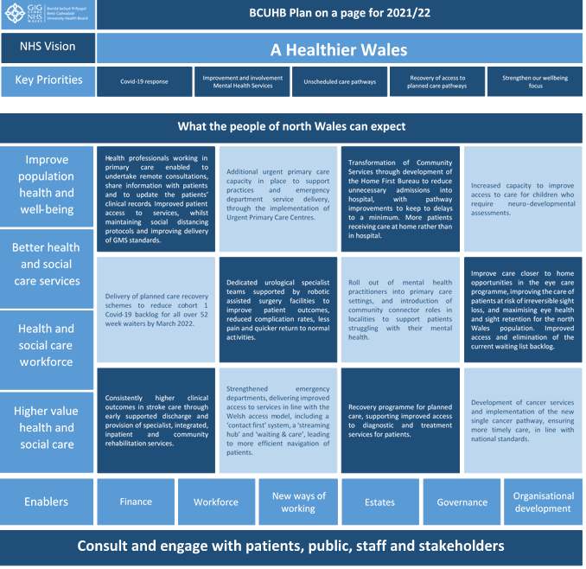

Introduction
Our Plan sets out the improvements we intend to deliver over the coming year, working with our staff, public, and partners. It recognises the need to refresh our thinking about the future of health and services, whilst also delivering here and now for the people of North Wales.
Vision & Strategy
The Health Board’s vision is to create a healthier North Wales, that maximises opportunities for everyone to realise their full potential, reducing health inequalities. This means that, over time, the people of North Wales should experience a better quality and length of life.
To do this we will:
- Improve population health and well-being through a focus on prevention;
- Improve the experience and quality of care for individuals and families;
- Enrich the well-being, capability and engagement of the health and social care workforce; and
- Increase the value achieved from funding of health and care through improvement, innovation, use of best practice, and eliminating waste.
The Health Board’s longer term strategy for health, well-being and healthcare, Living Healthier, Staying Well (LHSW) set out how we intended to make progress. It has been three years since we developed this and the time is now right to pause and review to ensure that our strategy remains valid. To facilitate this we are beginning a review and refresh of LHSW, and will:
- Check in with our staff, patients, partners and public whether the principles are still valid
- Review our strategic priorities to ensure they are consistent with “A Healthier Wales”
- Address those elements of LHSW that proved challenging to implement e.g. an integrated system wide approach to healthcare and integrated care pathways
- Test the strategy is still relevant in the changed environment
- Provide the framework for development of a Clinical Services Plan

This refresh work will be completed by the autumn, in time to feed into the development of the integrated three year plan 2022/25. It will also provide the basis for the development of a new clinical services plan which will describe how we will deliver care in the future.
Changing the way we work – Engagement and Transformation
We recognise the need to build greater capacity and capability for transformation and improvement. This is critical to our ability to design and deliver our refreshed clinical strategy.
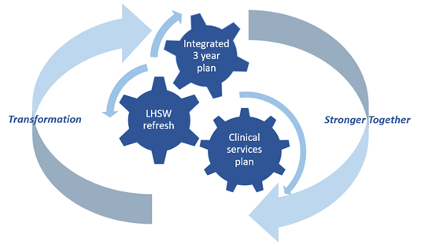
Successful transformation and improvement activities are not the concern of a single team, but rather something that needs to be embedded across the Health Board, through all of our systems and processes. To do this we will draw upon the experiences of other organisations and invest in a transformation and quality improvement (QI) approach, which is capable of maturing and informing our decision-making.
To inform and enable this transformation, we have committed to embark on a programme of work which aims to align each and every member of the organisation behind the goal of “One NHS organisation”, working with our partners and citizens to deliver co-ordinated seamless care or service for individuals. Our approach will enable the organisation to discover its current capability and answer the question: “What do we need to do as an organisation and system of care to succeed in the achievement of our purpose and goals?”
We are working in partnership with our people so that the solutions to the problems we face are co-produced with people who work across the organisation and understand the challenges. Our approach to this ambitious work programme, titled Mewn Undod Mae Nerth (Stronger Together) is set out in the diagram below -

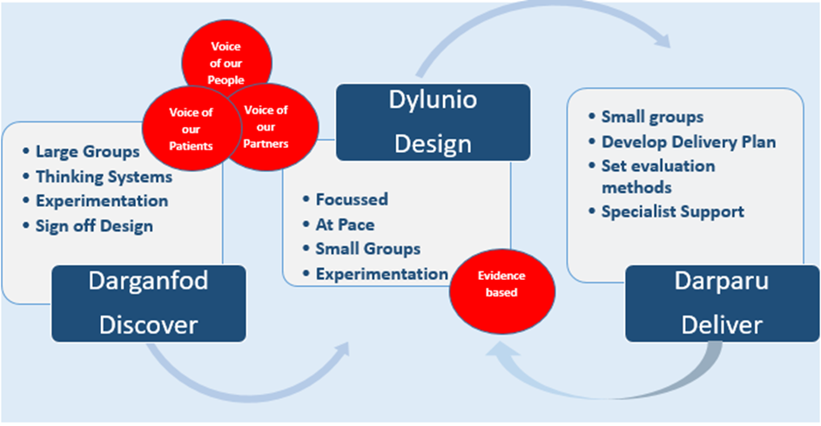
The goals and outcome measures have been established for the first phase (Discover), and work began in earnest at the beginning of April 2021. This programme will support transformation over a number of years, with the milestones set out below.

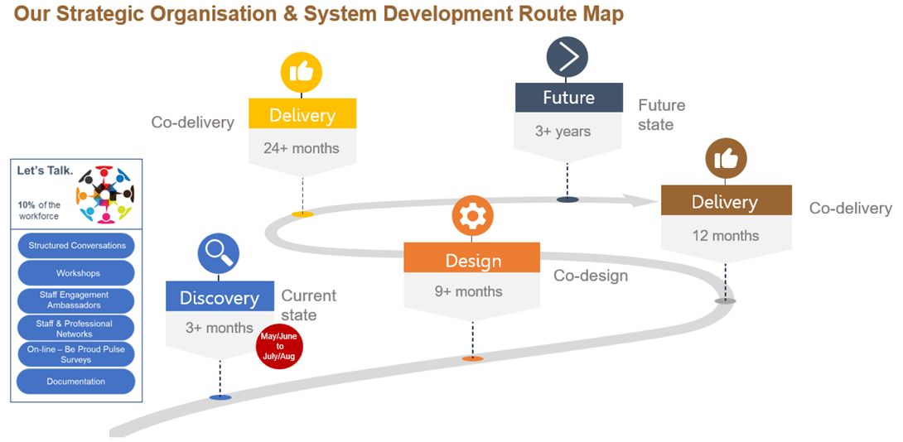

Immediate Priorities for 21/22
There are many immediate priorities which need to be addressed whilst we are building out longer term strategy and transformation capability. The following priorities have been identified for the year ahead.-



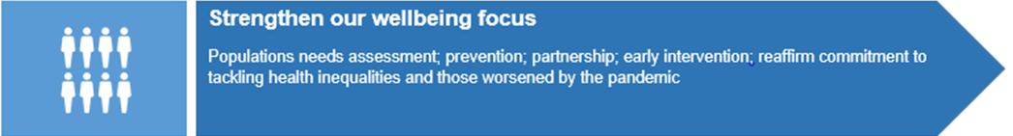

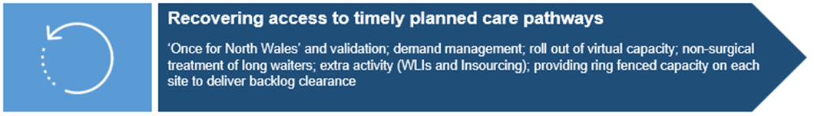

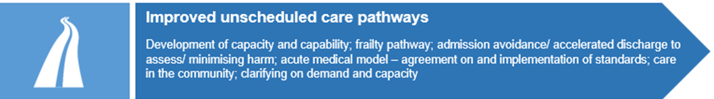

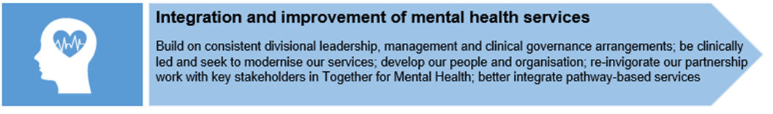

What the people of North Wales can expect

The priorities above will be addressed using our own staff and resources as well as drawing in extra capacity from external sources. To deliver sustainable improvement requires critical investments in capacity and resilience both in terms of physical capacity and workforce supply.
A number of significant developments within our plan are set out below to illustrate what our plan is seeking to deliver for our population in North Wales:
- Develop proposals for a Diagnostic and Treatment Centre approach in North Wales. This will provide dedicated capacity to address long waiting lists for diagnostic tests and surgery, as well as improving waiting times for cancer diagnosis and surgery.
- Working with Bangor University we will develop proposals for a transformational inter-professional Medical and Health Sciences School, to be established by 2025. This will allow us to align education and training to our clinical strategy, support the delivery of our research strategy and address key challenges in our medical and clinical workforce.
- Develop our Primary and Community Care Academy, including the establishment of a Dental Academy with a dental training unit and provision of dental services. We will develop an additional training hub to further support advanced practice training in primary care, the further development of the Physician Associates programme and piloting of ‘Project Flex’, a flexible approach to GP recruitment.
Key areas of improvement include:

- Further roll out of digital technology with more virtual appointments provided in primary care and within our hospitals. Access to appointments improved due to having more options for timely consultations. This will also reduce patients having to travel for services and reduce the risk of COVID-19 spread and will be safer for staff and patients;
- Improved care for children and young people in crisis so they are treated in the right place at the right time and as close to home as possible;
- Increased capacity will support improved access to care for children who require neuro-developmental assessments;
- Roll out of the mental health practitioner model and community connector role to localities to improve support to patients within primary care;
- The development of pathfinder urgent primary care centres to ensure timely, efficient care for patients with urgent primary care needs and reduce demand for minor illness / injuries on our Emergency Departments. The service will create more capacity for GP practices to better manage patients with more complex conditions;
- By strengthening our emergency departments, we will deliver improved access to services in line with the Welsh access model including a ‘contact first’ system, ‘streaming hub’, and ‘wait & care system’, leading to more efficient navigation of patients;
- Developments in cancer services and implementation of the new single cancer pathway will ensure more timely care for our patients in line with expected national standards;
- Patients will receive consistently higher clinical outcomes in stroke care through early supported discharge and provision of specialist integrated community in-patient rehabilitation services;
- The planned care recovery programme will support improved access to diagnostic and treatment services for patients;
- The eye care programme will optimise care closer to home and improve the care for patients at risk of irreversible sight loss, maximise eye health and sight retention for the North Wales population including improved access and elimination of existing waiting list backlog;
- The prehabilitation programme, including for example, conservative management for early onset osteoarthritis, will maximise patient fitness prior to treatment and avoid or shorten hospital stays wherever possible;
- Building capacity within to retain and sustain improvement through a network of 1800 champions, connectors and influencers in order to grow a BCUHB social movement of change;
- Dedicated urological specialist teams supported by robotic assisted surgery will improve patient outcomes, reduce complication rates and deliver improved access for patients with less pain and quicker return to normal activities;
- The Home First bureau (operating 08.00 – 20.00 daily) will support patients to return to the best life possible following their period of illness, through maximising the opportunity for active therapeutic input and support to patient discharge from hospital. This will reduce delay in transfers of care leading to shorter length of stays within hospitals and increase in patients returning home rather than having to be cared for in a community bed;
- Care home quality nurses will work with the care home sector to deliver safe effective care to the residents of North Wales. Quality of life will be enhanced by ensuring patients receive the care and support they need, have a positive experience of care and are safeguarded and protected from avoidable harm; and
- Implementation of an audiology led earwax management pathway will provide care closer to home, improve patient experience and reduce unnecessary onward referrals to secondary care ENT and audiology services.

Governance and Targeted Intervention
The actions set out above are intended to improve service delivery and address the specific areas identified in the Targeted Intervention Framework. The Board will oversee the delivery of the targeted intervention improvement plan through the use of maturity matrices for the four improvement domains which are:
- Mental Health Management;
- Strategy Planning & Performance;
- Leadership; and
- Engagement.
In May 2021 the Board agreed baseline reference points to reflect the current position in each domain, against which progress will be measured. Progress will be tracked bi-monthly by the Board with a formal review of progress every 6 months as part of the standard reporting arrangements to the Board. Improvement expectations for the second six-month period will be set in November 2021. Accountability for the delivery of actions required will be clearly articulated across the organisation with service areas held to account for their performance through the monthly accountability review process.
Resources
The Health Board has significant financial resources at its disposal to deliver the commitments in this plan. Allocations received and anticipated from Welsh Government total £1,789m. This includes specific additional allocations of :
- Strategic Support £82m
- COVID Costs £116m
- COVID Recovery £20m
We will deliver the commitments in this plan and deliver a break even position in year, to support the Health Board meeting the statutory duty to breakeven over a three year period, by the end of 2022/23.

Appendix 1: Summary of key performance metrics for 2021/22

 | Lead Executive  Director | 30 Jun  2021 | 30 Sept 2021 | 31 Dec  2021 | 31 Mar  2022
Number of people waiting over 52 weeks for planned care treatment  (inpatient, outpatient or day case) | Deputy CEO | 43,500 | 43,500 | 48,000 | 43,000
Number of people waiting between 36 and 52 weeks for planned care treatment  (inpatient, outpatient or day case) | Deputy CEO | 55,600 | 55,600 | 51,600 | 44,500
Compliance with the eye care measure | Deputy CEO | 45% | 55% | 70% | 80%
Compliance with the single  cancer pathway | Dir. of Therapies & Health Sciences | 65% | 67.5% | 70% | 72.5%
Number of people waiting over 8 weeks for a diagnostic procedure (excluding endoscopy) | Dir. of Therapies & Health Sciences | 3,600 | 2,000 | 500 | 0
Performance against the mental health measure Part 1a | Dir. of Public Health | 81% | 76.8% | 88.8% | 83.1%
Performance against the mental health measure Part 1b | Dir. of Public Health | 90% | 83.2% | 92.9% | 83.1%
CAMHS – time to assessment | Dir. Of Primary & Comm. Care | 30% | 40% | 50% | 60%
CAMHS – time to treatment | Dir. of Primary & Comm. Care | 25% | 40% | 60% | 60%
Emergency department & MIU compliance against the 4 hour performance target | Deputy CEO | 70% | 73% | 75% | 80%
Ambulance handover delays over 1 hour | Deputy CEO | 1,300 | 1,200 | 1,200 | 1,200
Number of people waiting over 12 hours in our emergency departments | Deputy CEO | 2,200 | 1,700 | 1,000 | 1,000

